**EYFS Characteristics of Effective Learning**

**Playing and exploring** – **engagement**

* Finding out and exploring
* Playing with what they know
* Being willing to ‘have a go’

**Active learning – motivation**

* Being involved and concentrating
* Keeping trying
* Enjoying achieving what they set out to do

**Creating and thinking critically** – **thinking**

* Having their own ideas
* Making links
* Choosing ways to do things

The Early Years Curriculum is split into 7 areas. These areas are set out below. There are 3 Prime Areas: Personal, Social and Emotional Development, Physical Development and Communication and Language. There are 4 specific areas: Literacy, Maths, Understanding the World and Expressive Arts and Design.



**Communication and Language**



The children will continue to have Show and Tell on a Monday to continue to develop their communication and speaking skills**. Please can the children bring items that they have made or has special meaning, relate to an outing or family event, using their Learning Journals.** We continue to develop the children’s “Talk for Learning” skills, encouraging them to ask “how” and “why” questions about their own experiences in response to events or stories. We will encourage the children to develop their listening and understanding by following instructions and holding “to and fro” conversations in pairs or small groups. You can practise these skills at home.

**Personal Social Emotional Development**



Our “theme” for this term is “Keeping Ourselves Safe”. We will look at what is safe to put in or on our bodies, safety at home and when we are out and about, staying safe online and looking at people who help keep us safe.

Alongside this there will be daily opportunities to reflect on our feelings and those of others, how we interact with each other, regulate our emotions and build resilience. Please encourage your child to talk about these scenarios at home.

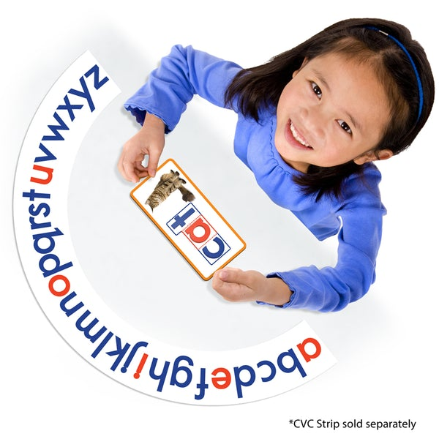

**SAPLINGS**

**SPRING TERM – January 2022**





**Where will our learning journey take us this term?**

From Week 2 our starting point will be the book “Bear snores on”. Depending on the children’s interests, the planning may change to suit! If you have any resources or experiences relating to our topics that you can share with us, please do let us know.

All areas of the EYFS are inter- connected so the children will be learning and practising a variety of skills at any one time.  We continue to link our learning to our school values – love, respect and responsibility.   We will do everything in love.  We will show respect for each other and our environment.  We will take responsibility for making good choices in our learning and play.  In addition we are a UNICEF Rights Respecting School, so we will be looking at Article 16.

**At Ide Hill Church of England Primary, we seek the 'abundant life' that Jesus promised (John 10:10) - pupils and staff flourish. From the tiny Saplings in Reception to the mighty Oaks of Year 6, children are nurtured through the learning and experiencing of respect, responsibility and love - and the greatest of these is love  (1 Corinthians 13:13).**



**Physical Development/PE**

Our focus will continue on healthy living this term – in terms of diet, exercise and hygiene. As well as our PE sessions with Mr Taylor we will be refining our gross and fine motor skills every day, using a variety of skills both inside and outside. These all help to strengthen our core muscles and co-ordination, as well as develop our muscles to support our pencil grip for writing. Encourage your child to be climb safely or learn to do up their coats using a zip or buttons independently.

**Understanding the World**



We are hoping to encourage some budding researchers this term with investigations and fact-finding activities about Winter including hibernation, ice and water. We will be celebrating the Chinese New Year in February, learning and respecting how another culture celebrates their New Year. The children will continue Forest School activities this term, enriching their learning and knowledge and understanding of the world, as well as using our school values of love, respect and responsibility for the world around them. Please support learning at home by enjoying the natural world together, focusing on how we are all responsible for it. Mungo will be looking forward to more adventures at weekends…so watch out for him coming home with your child on a Friday! Perhaps you can look at some winter themes online together, reminding your child about staying safe online.

**R****E**

Our focus, this term, will be on the big question: What do Christians believe is special about Jesus and the message he brings? We will explore this in a variety of ways and will start by recapping on what we know already about God and sending his son at Christmas. You can look at the parables from the New Testament, discuss their messages and how we can link them to our school values: love, respect and responsibility.

**Literacy**

Our daily phonics sessions will help prepare us to write about winter using fiction and non-fiction texts, as well as our own interests. The children will be consolidating their speed sound knowledge and will start learning the next set of sounds, as we develop our reading and writing skills. We will also be developing the children’s knowledge of “red” & high frequency words too (I will continue to email our progress every week), as they begin to write simple sentences, captions or lists and tackle trickier reading books or phonics games with increasing independence. We will be encouraging the children to record their ideas and drama using IT equipment to help them remember their ideas. **Please continue to read daily with your children at home** and use their reading records to let us know how they are getting on. We will be reading regularly with the children in class too. You can also support at home by encouraging your child to talk, draw and write about what interests them and use non-fiction books to explore their own interests. Focus on correct letter formation.



**French**

The children are enjoying learning a little sprinkling of French. This term we will continue to explore new words both in English and French and celebrate the diversity of culture and language.

**Expressive Arts & Design**



The children will be putting their investigation skills to the test finding out what materials are best to keep warm and designing their own snug dens. We will be continuing with our music sessions and the focus this term will be tempo changes. The children will have the opportunities to compose and choreograph their own productions using the stimulus of the winter season and Chinese New Year. We will be creating some Chinese and winter artwork using a variety of media! Can you mix some wintry colours at home to make a “cold” picture?

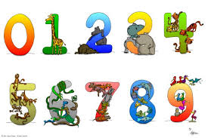

**Mathematics**

Alive in 5:

* Introducing zero, comparing numbers to 5 and composition of 4 and 5
* Compare mass and capacity

6,7,8

* Making pairs
* Combining groups
* Length and Height
* Time

The children will be mastering their understanding of numbers 0-5 and then 6, 7 and 8 in a variety of activities. We will be enjoying capacity and measurement alongside our number skills and the children will be able to “bump” into this learning across all areas of the curriculum in their play. Please encourage your child to count objects and actions carefully, find different ways to make numbers up to 5 with objects around the house and use vocabulary associated with capacity, measurement and time.

Dear Parents

Welcome back! We hope you have had a wonderful Christmas break and wish you all a very happy new year! A huge thank you for the very generous Christmas gifts we received! We were very touched by them and all of your lovely messages.

So, here we are at the beginning of a new term. It can be very cold and wintry so the children need appropriate NAMED warm clothing every day in order to enjoy being inside and out during the day. Please continue to use the Learning Journals with your child so we can share their interests at Show & Tell sessions on Mondays or a WOW moment they have had at home. PE will continue on Mondays and Thursdays this term, as will Forest School on a Thursday. Thank you for your continued support and we look forward to working with you all this term – our door is always open, should you need to discuss anything.

Mrs Daniels, Mrs Drysdale and Miss Bruce