

**IDE HILL CHURCH OF ENGLAND PRIMARY SCHOOL**

**HANDWRITING POLICY**

**REVIEWED September 2024**

**TO BE REVIEWED September 2027**

**This policy is subject to review and evaluation by the Headteacher and the Governing Body.**

|  |  |
| --- | --- |
| **Signed by Headteacher, Miss Alexander** | **Date** |
| **Signed by Chair of Governors, Mrs Anne Fletcher** | **Date** |

This policy should be read in conjunction with the following policies:

* Marking and Expectations
* Teaching and learning policy
* Early Years Policy

**Aims:**

* To enable the children to write clearly, fluently and quickly so that they can be successful with the everyday demands of life and school.
* To teach children the conventional ways of forming letter shapes, both lower case and capitals, through purposeful guided practice in order to foster a comfortable and legible handwriting style.
* To comply with statutory requirements set out in the national curriculum.
* To be able develop and use a cursive script across the curriculum.

**Teaching and Learning**

Handwriting is a skill which needs to be taught explicitly. Since handwriting is essentially a movement skill, correct modelling of the agreed style by the teacher is very important.

Consistency in the attitudes displayed, the methods employed and the models provided is the key to effective learning. A mixture of whole class, small group and individual teaching should be planned for.

The role of the teacher is to:

- follow the school policy to help each child develop legible and fluent handwriting;

- provide direct teaching and accurate modelling;

- provide resources and an environment which promotes good handwriting;

- observe pupils, monitor progress and determine targets for development.

**The learning environment**

The Reception Class and year 1 will have a dedicated writing area, which provides lots of opportunities for children to write.

All classes will have a range of handwritten notices on display so that children see and read a balance of word processed font and handwritten script.

The children are taught to form their letters within their phonics lessons and these letters, with their formation guides, are on display in Reception Class and Year 1. The children are taught a script to form the letters which is based on the formation of the rocket phonics letters.

**Inclusion**

The vast majority of pupils are able to write legibly and fluently. However, some pupils need more support and a specific individual or group programme (e.g. Jump Ahead or Speed up!) is drawn up in consultation with the SEN co-ordinator.

All teachers should be aware of the specific needs of left-handed pupils and make appropriate provision:

- Paper should be positioned to the left for right handed pupils and to the right for left handed pupils and slanted to suit the individual in either case;

- Pencils should not be held too close to the point as this can interrupt pupils’ line of vision;

- Pupils should be positioned so that they can place their paper to their left side;

- Left-handed pupils should sit to the left of a right-handed child so that they are not competing for space.

- Models should be placed on the left hand side of a right handed child and on the right hand side of a left hand child.

**Entitlement and curriculum provision**

In Reception Class handwriting is taught within the children’s daily phonics lesson.

In Y1 to Y6 handwriting is taught 3 times a week using a handwriting scheme ‘Letter Join’. Children will also be reminded about presentation and letter formation in all phonics, spelling, English lessons and across the curriculum. Shared and guided writing provides many opportunities for the modelling and monitoring of handwriting.

Patterns will be taught in order to develop a smooth flowing style throughout the school.

Children learn letter formation using “shape” families:

|  |  |  |  |
| --- | --- | --- | --- |
| **i, l, t** | **u, w, e** | **c, o** | **a, d** |
| **n, m, h** | **j, y** | **g, q** | **b, p, k** |
| **v, s, r** | **f, z, x** |  |  |

At Ide Hill School, printed letters will be taught in Reception and Year 1 as follows:

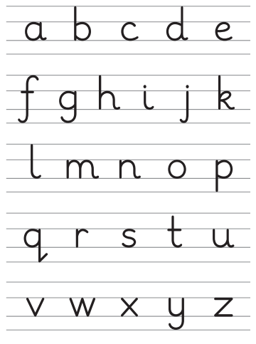

From Year 2 upwards cursive letters will be taught with a lead in from the line as follows:

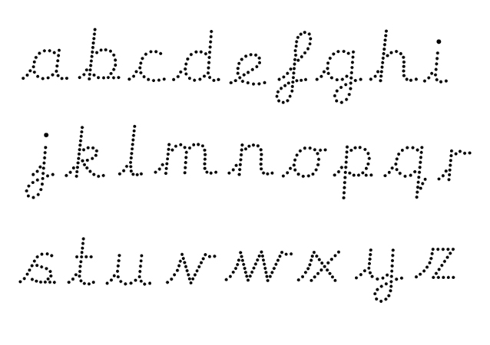

The expectation is that all children will be using a joined script from Year 3 onwards.

**National Curriculum Requirements**

The focus on handwriting in the new curriculum is much greater, highlighting its importance and making the connection between a child’s handwriting and their composition and spelling ability.

**Progression:**

|  |  |
| --- | --- |
| **EYFS:** | At the start of the year, the children develop their fine motor control with a range of activities including cutting, threading, dough disco and wiggle and squiggle. Children will then be shown the correct way to hold a pencil using the ‘pinch and flick’ method. The children are taught the letter formation, in conjunction with their phonics. These sessions take place daily and the children will learn a script to form the letters based on the formation of the Rocket Phonics letters.  The children learn the letter sounds together with their shapes as they are presented by the scheme. This allows them to develop a secure knowledge of how to form the letters. Children will, when developmentally ready, be supported to develop their handwriting so they use their phonics skills to write with independence, in line with the Early Learning Goals for Writing.    X-rays of a child’s hand at approximately 7 years of age, in comparison to X-rays of a 5 year old during the Early Years Foundation Stage (Reception). |
| **Y1** | In Year 1, the children will continue to develop their handwriting skills. The expectation is that all children will be forming their printed letters correctly, by the end of the year.  The children will be taught to:   * use spaces between their words * form their writing consistently in size * sit their writing on the line. * form digits 0-9 correctly * form capital letters |
| **Y2** | When children are developmentally ready, they will be taught the pre-cursive style including how to:   * form cursive lower-case letters in the correct direction, starting from the line and joined correctly. * form capital letters * form digits 0-9 * understand which letters belong to which handwriting ‘families’ (i.e. letters that are formed in similar ways) and to practise these. * form lower-case letters of the correct size relative to one another * start using some of the diagonal and horizontal strokes needed to join letters and understand which letters, when adjacent to one another, are best left unjoined * write capital letters and digits of the correct size, orientation and relationship to one another and to lower case letters * use spacing between words that reflects the size of the letters. |
| **Y3 -4** | Pupils should be taught to:  * Use the diagonal and horizontal strokes that are needed to join letters and understand which letters, when adjacent to one another, are best left unjoined  * Increase the legibility, consistency and quality of their handwriting [for example, by ensuring that the down strokes of letters are parallel and equidistant; that lines of writing are spaced sufficiently so that ascenders and descenders of letters do not touch. |
| **Y5 -6** | Pupils should be taught to:  *Write legibly, fluently and with increasing speed by  *Choosing the writing implement that is best suited for a task. |

**Presentation**

Children in Years 3 and 4 will have the opportunity to earn a pen licence. This will be presented to them by their class teacher once they have identified consistently good practice. If there is a noticeable change in the child’s handwriting then they may lose the privilege of using a pen for a period of time. It is expected that all children are writing in pen in upper key stage two.

All staff will work towards a cursive style and model this whenever they are writing in front of the children or presenting children with writing they have done.

**Supporting Material**

http://mamaot.com/3-tricks-to-help-kids-learn-to-hold-their-pencil-correctly/

http://www.teachhandwriting.co.uk/index.html

http://www.nha-handwriting.org.uk/

http://www.bdadyslexia.org.uk/parent/help-with-handwriting