IDE HILL PRIMARY SCHOOL
RELATIONSHIPS EDUCATION, RELATIONSHIPS AND SEX EDUCATION
AND HEALTH EDUCATION POLICY

REVIEWED: MAY 2021
REVIEW DATE: MAY 2022

THIS POLICY IS CURRENTLY UNDER REVIEW

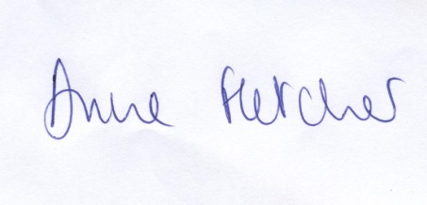
Chair of Governors Signature Date:

Headteacher Signature Date:

This policy is subject to review and evaluation by the Headteacher and Governing Body.

Introduction:

At Ide Hill CE Primary School, our ethos and vision "Do everything in love" shapes all that we do. We aim for children to form a positive attitude towards school and positive attendance. Our values of Love, Respect and Responsibility support us in our aim for all children to develop a love of God, a love learning, a love of everyone and a love of life.

Ide Hill CE School is a Silver Rights Respecting school. We ensure that all members of our school community are aware of the UN convention for the rights of the child. Article 28 states: Every child has the right to an education. This policy support’s children’s entitlement to this right. Article 3 states: The best interests of the child must be top priority in all decisions and actions that affect children. This policy has been written in the best interests of the children.

Policy development
This policy has been created in consultation with members of our school community. We have taken the following approach to the review of this policy:
- The policy has been reviewed by members of the school’s senior leadership team and PSHE subject leader using guidance documentation obtained from Kent County Council and from the Diocese of Rochester.
- All school staff have been given the opportunity to read the policy and to make recommendations.
- Parents and governors have had the opportunity to read the policy and raise questions.
- Once finalised, this policy was ratified by the governing body including the governor with responsibility for Safeguarding.

Documents that have informed the school’s Relationships Education Policy include:
- Education Act (1996)
- Learning and Skills Act (2000)
- Education and Inspections Act (2006)
- Equality Act (2010),
- Guidance “Relationships Education, Relationships and Sex Education and Health Education in Church of England Schools, (November 2019)
- Keeping children safe in education (September 2020)
- Children and Social Work Act (2017)
This policy should be read in conjunction with the following school policies:
- Safeguarding and Child protection policy
- Digital Technology Policy
- Equality Scheme
- Behaviour Policy
- Anti Bullying Policy
- Wellbeing policy

Purpose and Principles
At Ide Hill Church of England School, we believe in providing every child with open, honest, accurate and age-appropriate lessons all about relationships. The greatest commandment Jesus taught was to love God and to love your neighbour. Within this commandment is the foundation of the Christian view of relationships. At Ide Hill Church of England School our relationship education seeks to live out this command and explore how we can ‘love our neighbour’ through what we say and do. Our school focusses on the importance of relationships and the qualities and character needed to sustain the best relationships that honour each other whether within a friendship, family relationship or romantic relationship. Each child is a unique being, a child of God, loved and accepted. As such, our school seeks to enable children to develop through an inclusive programme of teaching that is based on Christian principles, which both respects the human body and seeks to ensure health and wellbeing.

Relationship Education forms an important part of the PSHE curriculum and is an essential and integral part of the broad and balanced curriculum taught at our school. Our provision for Relationship Education contributes towards the school’s ethos, supporting children and young people in their development. We encourage children to play a positive role in contributing to the life of the school and the wider community in order to develop their sense of self- worth, respect for themselves, respect for others and to understand their rights and responsibilities. Through the school’s vision and values, we aim to develop children’s knowledge, skills, opinions, strategies and confidence - enabling them to cope with life and live safely and happily in the modern world. We value our close partnership with our school community and will promote open and informative two-way communication with parents and carers.

We aim to provide parents and carers with accurate information about what their child is learning in school and to provide the best learning environment and opportunities for our children. Our Relationships Education curriculum is inclusive and meets the needs of all children, including those with special educational needs or disabilities (SEND). We also aim to promote gender equality and represent the LGBT+ community.

Through our Relationships Education provision, we aim to provide all pupils with:
- the knowledge and understanding of a variety of relationships;
- the ability to identify any concerns they have about a relationship;
- coping strategies and an awareness of how and where to seek support;
- an understanding of their rights and responsibilities within a range of relationships;
- an awareness of the process of growing up and the changes they and others will experience;
- an understanding of the characteristics of positive relationships.

This policy sets out our school's approach to Relationships Education; a statutory component of the PSHE and Citizenship curriculum from September 2020. Thorough this policy we aim to set out:
- the purpose of Relationships Education and the intended outcomes for pupils
- what is covered in our curriculum
- how the curriculum will be delivered to children

We undertake to follow the principles in the Church of England Charter for faith sensitive and inclusive relationships education, relationships and sex education (RSE) and health education (RSHE) which is underpinned by two key biblical passages:

“So God created humankind in his image, in the image of God her created them” Genesis 1:27 NRSV

“I have come in order that you might have life – life in all its fullness” John 10:10 GNB
Statutory Regulations
From September 2020, all primary schools must deliver Relationships Education. Under the Education Act 2002/Academies Act 2010, all schools must provide a balanced and broadly-based curriculum which promotes the spiritual, moral, cultural, mental and physical development of pupils at the school and of society, and prepares pupils at the school for the opportunities, responsibilities and experiences of later life.

Relationships Sex Education and is an important part of PSHE education (DfE 2014). This states that:
- ‘All children, including those who develop earlier than average, need to know about puberty before they experience the onset of physical changes’ (1.13)
- Children should learn ‘how a baby is conceived and born’ before they leave primary school (1.16)
- All schools must have due regard for the Secretary of State’s guidance; this is a statutory duty.
- It is compulsory for all maintained schools to teach the parts of sex education that fall under National Curriculum Science, which must be taught to all pupils of primary and secondary age eg the biological aspects of puberty and reproduction (Education Act 1996, National Curriculum 2014).
- Schools have a legal duty to promote the well- being of their pupils (Education and Inspections Act 2006, Section 38) and RSE contributes to this duty.
- School Governors are in law expected to give ‘due regard’ to the RSE 2000 guidance and to maintain an up to date RSE policy, which must be made available to parents (Learning Skills Act 2000).
- Parents have a right to withdraw their children from any school RSE taught outside of the Science curriculum (Education Act 1996 and Learning Skills Act 2000).

Curriculum Intent Statement: Children should gain knowledge, skills and vocabulary across a range of subjects which they can relate to wider concepts and a real understanding. Activities should develop as the children progress through school and should be precisely mapped to ensure progression. The National Curriculum should not be considered a glass ceiling for each key stage but recognition of bare minimums for knowledge and understanding.

Definition of Relationships Education
Relationships Education teaches the fundamental building blocks of positive relationships, focusing on friendships, family relationships, and relationships with other peers and adults.
Children need to learn about relationships, the emotional, social and physical aspects of growing up, human sexuality and sexual health in an age-appropriate way. Through health education, children will learn about physical health and fitness, healthy eating, mental wellbeing, drugs, alcohol and tobacco.
Relationships and Sex Education (RSE) teaches the importance of stable and loving relationships (which includes marriage), respect, love, responsibility and care. Through RSE children will learn about puberty, how a baby is conceived and born, body ownership, and safeguarding. All of this helps to keep them safe.

Relationships Curriculum

What will be taught?
At Ide Hill CE School, we use the SCARF curriculum to deliver relationships education to children from Reception to year 6. The RSE lessons provided within SCARF curriculum provides the framework for a whole-school approach to improving children’s wellbeing and progress, based the SCARF values: SAFETY, CARING, ACHIEVEMENT, RESILIENCE and FRIENDSHIP and are designed to help children to be safe, healthy and happy.

The themes for our SCARF Relationships Education Scheme of Work are as follows:

Reception | Year 1 | Year 2 | Year 3 | Year 4 | Year 5 | Year 6
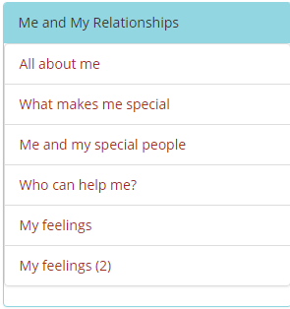 | 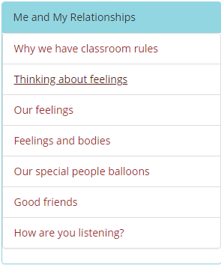 | 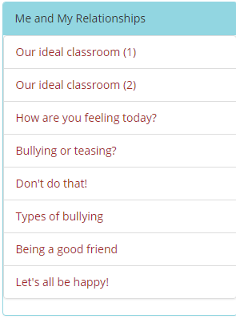 | 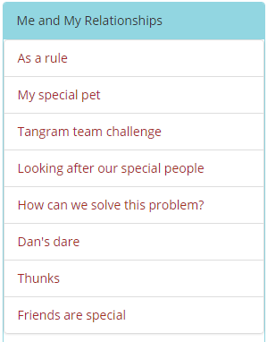 | 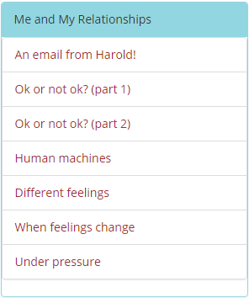 | 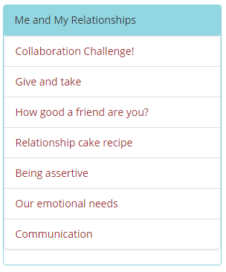 | 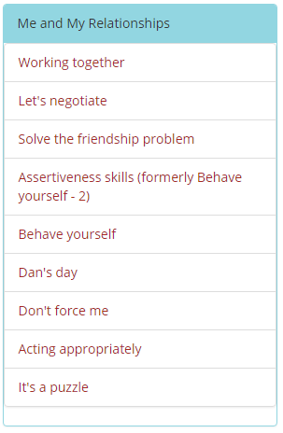
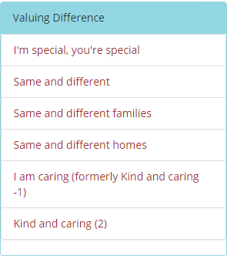 | 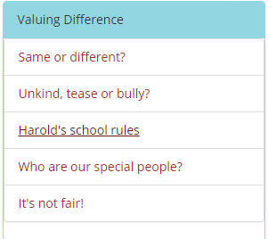 | 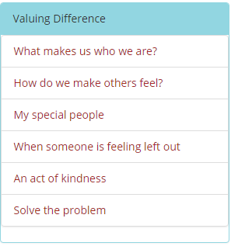 | 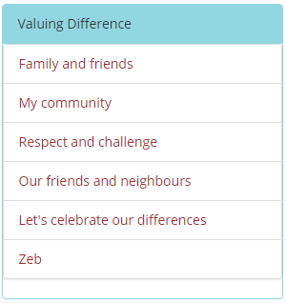 | 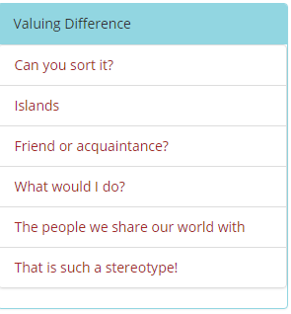 | 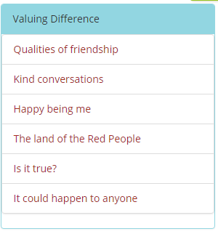 | 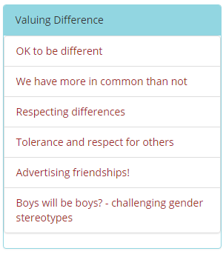
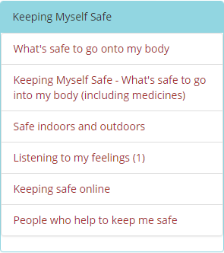 | 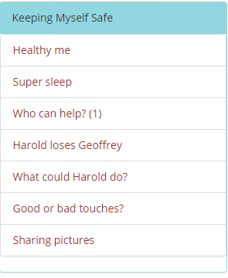 | 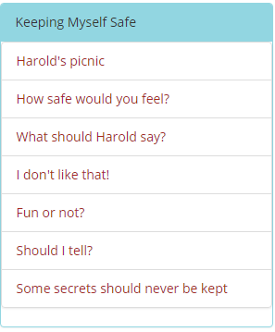 | 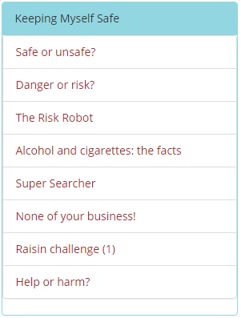 | 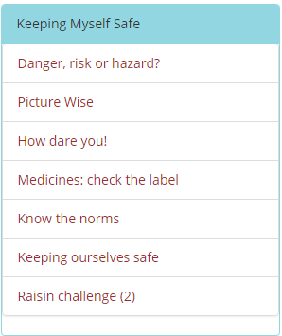 | 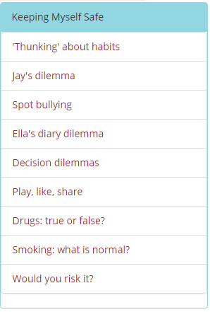 | 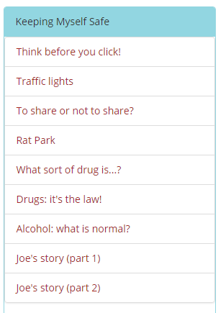
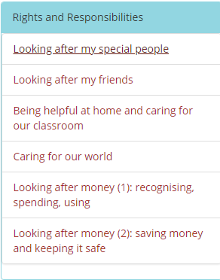 | 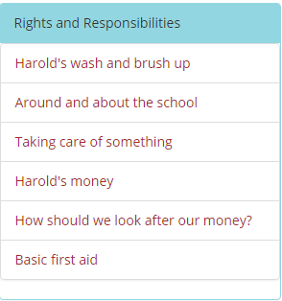 | 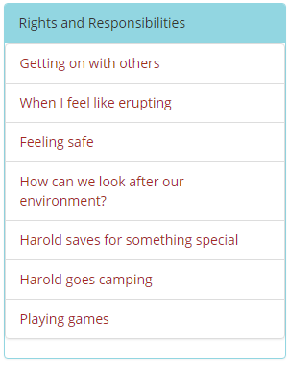 | 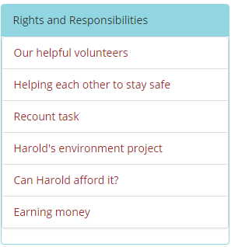 | 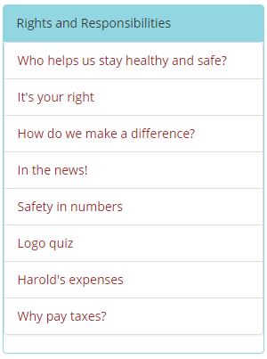 | 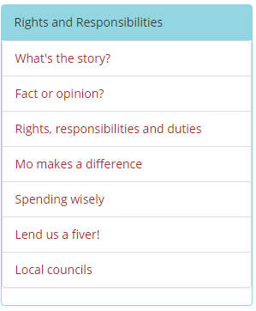 | 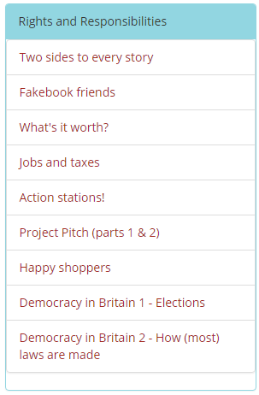
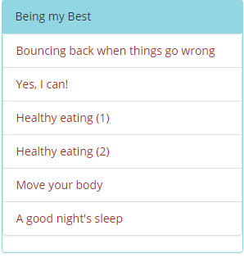 | 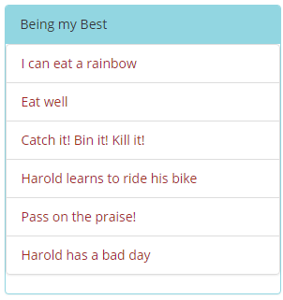 | 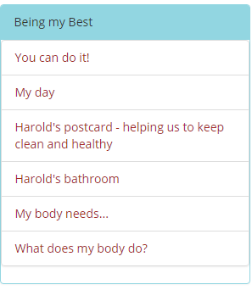 | 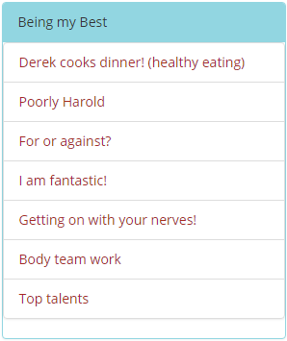 | 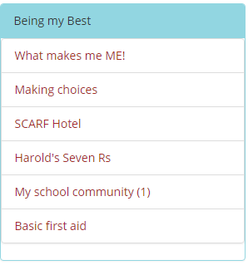 | 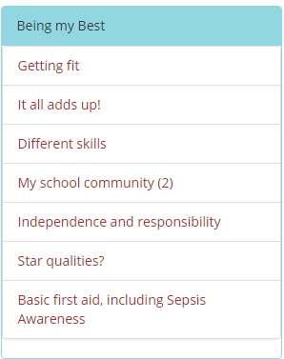 | 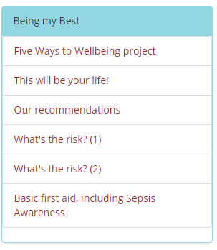
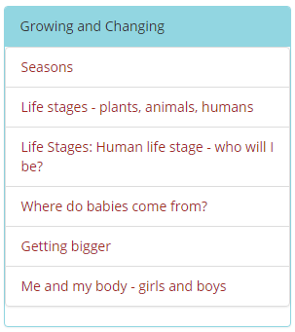 | 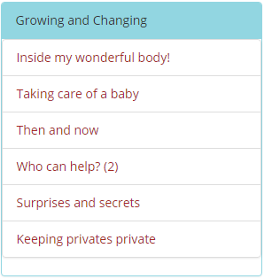 | 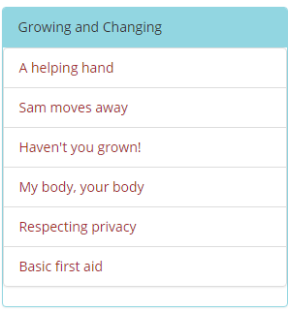 | 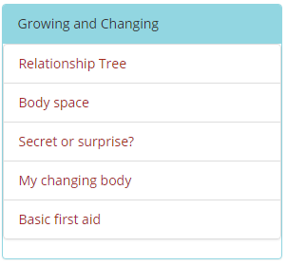 | 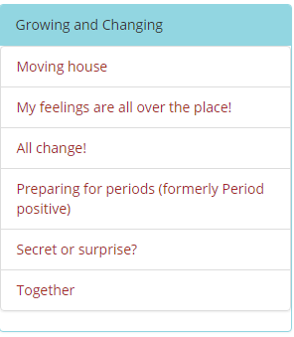 | 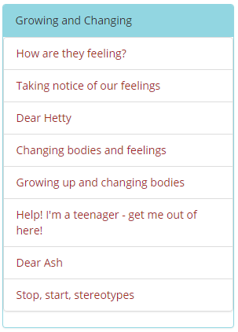 | 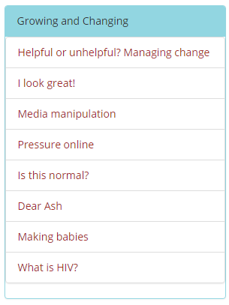

How will children be taught?
Relationships Education lessons will be delivered through PSHE, Computing and in Science. Ground rules will be established in class and children reminded of these. Special consideration will be given when teaching particularly sensitive content and staff will be fully aware of the children in their class and how they might relate to the lesson content.
We aim to create and maintain a safe environment within which all children feel able to ask questions and discuss issues openly. For any child wishing to discuss something confidential, relating to the lesson content, an opportunity will be provided. In order to meet the needs of all children and to make our lessons engaging, we aim to deliver our Relationships Education curriculum through a variety of teaching methods and interactive activities, including: whole class, group work, 1:1, and using film/video.
The school will attempt to deal factually with children's questions as they arise. This will be done within the context of family life and growing up. The teacher will be aware of the maturity of the class and will match carefully the teaching level to their level of understanding.
Safeguarding
All schools are required by the Education and Inspections Act 2006 to ‘promote the well-being of pupils at the school’. We are committed to the well-being of our pupils. In the classroom, the aim is to strike a balance between helping pupils to feel respected, safe and able to participate fully and openly while still protecting privacy and safeguarding welfare.
Effective teaching and learning in PSHE / RSE actively encourages pupils to share thoughts and voice opinions, so it is important to establish boundaries and clarify at the outset with pupils what will happen to any personal information they might disclose in the classroom. Within school, the following protocol must be followed:
- Everyone has the right to be listened to and supported.
- Staff will only talk in a professional manner about pupils and their families.
- Information is shared on a strict need to know basis where the best interests of that person are central.
- School staff can never offer unconditional confidentiality; this needs to be clearly understood from the outset.
Potential safeguarding issues are treated seriously and procedures are invoked accordingly and appropriately as per the school Safeguarding Policy.
- Any pupil disclosures will be managed as per the school Safeguarding Policy.
- Ground Rules will always be established by teachers in order to create a ‘safe environment’ in which children do not feel: embarrassed or anxious about unintended or unexpected questions or comments from pupils. These ground rules are:
- No one will have to answer a personal question; No one will be forced to take part in a discussion;
- Only the correct, scientific names for body parts will be used;
- Meanings of words will be explained in a factual and sensible way.
- Difficult or explicit questions do not have to be answered directly but may be answered individually later, at a time, with honesty and due regard for the age and maturity of the child as well as being within the school’s agreed framework of values.
- Other professionals sometimes work to a different code of conduct e.g. school nurses. This will always be conveyed clearly in order to minimise confusion and breakdown of trust
- Distancing techniques will be used to help teachers to avoid embarrassment and protect pupils’ privacy by depersonalising discussions.
- All child Protection concerns will be brought to the attention of the Designated Child Protection Officer as per the Child Protection and Safeguarding Policy.

Roles and Responsibilities
The Governing Body will
- be actively involved in the consultation process for this policy
- understand the process for the review of this policy
- ratify the Relationship Education policy

The Head Teacher will
- Will be responsible for ensuring that Relationship Education is taught consistently across the school.
- Manage requests for pupils to be to withdrawn from non-statutory components of Relationship Education.

Staff are responsible for
- Delivering Relationship Education in a sensitive way
- Modelling positive attitudes to Relationship Education
- Monitoring progress of pupils and responding to pupil’s needs.
- Responding appropriately to pupils whose parents wish them to be withdrawn from the non-statutory components of Relationship Education
- Notifying parents by letter / email before any year group embarks upon its RSE programme to detail the RSE programme overview and to remind parents of their right to withdraw their child from RSE lessons.
- Write to parents of children in years 4 – 6 to offer the opportunity to view teaching resources before the content is taught to the children (e.g. video clips, images etc.). Parents may request a meeting with the class teacher by making an appointment via the school office. Before the teaching of the ‘How are babies made’ unit in Year 6, parents will be invited in to view the materials.

Pupils are expected to
- engage fully in Relationship Education
- treat others with respect and sensitivity.
Parents and Carers
- to be aware of subject content in each year group
- to reinforce or extend teaching appropriately within the home context.

Assessment, recording and reporting:
Teaching and learning of PSCHE and RSE will be assessed through a range of assessment methods including:

- Assessment for learning
- Peer Assessment
- Teacher Assessment
- Student self assessment

Equal Opportunities:
We recognise and celebrate that God has made each of us as a unique human being and we are all equally valued. Abusive, disrespectful and judgmental comments or attitudes will never be tolerated.

The school’s equal opportunities policy applies to all areas of the curriculum, including Relationships Education. Where appropriate teaching materials and activities reflect the ethnic, and cultural diversity of society. We will not stereotype, in terms of: faith, race, gender, cultural and sexual orientation. Pupils’ religious beliefs are always respected. We are committed to the provision of RSE to all of our pupils. Pupils with special or additional educational needs will be supported in their learning and understanding.

The Equality Act 2010 covers the way the curriculum is delivered, as schools and other education providers must ensure that issues are taught in a way that does not subject pupils to discrimination. Schools have a duty under the Equality Act to ensure that teaching is accessible to all children and young people, including those who are lesbian, gay, bisexual and transgender (LGBT). By teaching inclusive RSE we will foster good relations between pupils, tackle all types of prejudice – including homophobia – and promote understanding and respect

Parents’ Right to Withdraw
The DfE recommends that all primary schools should have a sex education programme tailored to the age and the physical and emotional maturity of the pupils. However, it does state that (p. 23):

"The national curriculum for science also includes subject content in related areas, such as the main external body parts, the human body as it grows from birth to old age (including puberty) and reproduction in some plants and animals."

"It is important that the transition phase before moving to secondary school supports pupils’ ongoing emotional and physical development effectively...It (the sex education programme) should ensure that both boys and girls are prepared for the changes that adolescence brings and – drawing on knowledge of the human life cycle set out in the national curriculum for science - how a baby is conceived and born."

Parents do not have the right to withdraw their children from Relationships Education. Parents do however have the right to withdraw their children from the non-statutory/non-science components of sex education within the curriculum. Sex education includes puberty, conception, reproduction and birth. Puberty is already statutory under Health Education and National Curriculum Science. Birth and reproduction are also included in Science National Curriculum so parents cannot withdraw children from this teaching.

Parents can however withdraw children from specific teaching on sexual intercourse and IVF within the Y6 “Making Babies” unit.

Those considering withdrawing their child from this additional teaching within this unit are asked to speak with their child's class teacher in order to find out more about this before submitting a formal request in writing to the Headteacher. Please note that children cannot withdraw from the whole unit, they must still receive the statutory /science elements of teaching.

SCARF Relationships Curriculum Learning Outcomes:

 | Year R | Year 1 | Year 2 | Year 3 | Year 4 | Year 5 | Year 6
Appropriate touch  Cosent | All about me  Talk about similarities and differences.  Name special people in their lives.  Describe different feelings.  Identify who can help if they are sad, worried or scared.  Identify ways to help others or themselves if they are sad or worried. | Good or Bad touches  Understand and learn the PANTS rules;  Name and know which parts should be private;  Explain the difference between appropriate and inappropriate touch;  Understand that they have the right to say “no” to unwanted touch;  Start thinking about who they trust and who they can ask for help. | My body, your body  Identify which parts of the human body are private;  Explain that a person's genitals help them to make babies when they are grown up;  Understand that humans mostly have the same body parts but that they can look different from person to person. | Body Space  Understand what is meant by the term body space (or personal space);  Identify when it is appropriate or inappropriate to allow someone into their body space;  Rehearse strategies for when someone is inappropriately in their body space. | Islands  Understand that they have the right to protect their personal body space;  Recognise how others' non-verbal signals indicate how they feel when people are close to their body space;  Suggest people they can talk to if they feel uncomfortable with other people's actions towards them. | Taking notice of our feelings  Identify people who can be trusted;  Understand what kinds of touch are acceptable or unacceptable;  Describe strategies for dealing with situations in which they would feel uncomfortable, particularly in relation to inappropriate touch. | Acting Appropriately  Recognise that some types of physical contact can produce strong negative feelings;  Know that some inappropriate touch is also illegal.
 | What makes me special  Talk about similarities and differences.  Name special people in their lives.  Describe different feelings.  Identify who can help if they are sad, worried or scared.  Identify ways to help others or themselves if they are sad or worried. |  | Fun or not?  Recognise that some touches are not fun and can hurt or be upsetting;  Know that they can ask someone to stop touching them;  Identify who they can talk to if someone touches them in a way that makes them feel uncomfortable. |  |  |  | Fakebook friends  Know the legal age (and reason behind these) for having a social media account;  Understand why people don’t tell the truth and often post only the good bits about themselves, online;  Recognise that people’s lives are much more balanced in real life, with positives and negatives.
 |  |  | I don’t like that.  Recognise that body language and facial expression can give clues as to how comfortable and safe someone feels in a situation;  Identify the types of touch they like and do not like;  Identify who they can talk to if someone touches them in a way that makes them feel uncomfortable | None of your business!  Know that our body can often give us a sign when something doesn't feel right; to trust these signs and talk to a trusted adult if this happens;  Recognise and describe appropriate behaviour online as well as offline;  Identify what constitutes personal information and when it is not appropriate or safe to share this;  Understand and explain how to get help in a situation where requests for images or information of themselves or others occurs.
Some secrets should never be kept
Identify how inappropriate touch can make someone feel;

Understand that there are unsafe secrets and secrets that are nice surprises;

Explain that if someone is being touched in a way that they don’t like they have to tell someone in their safety network so they can help it stop.
Respecting privacy
Explain what privacy means;

Know that you are not allowed to touch someone’s private belongings without their permission;

Give examples of different types of private information.

Adoption |  |  |  | Family and Friends  Recognise that there are many different types of family;  Understand what is meant by 'adoption' 'fostering' and 'same-sex relationships.' |  |  | Making Babies  Identify the changes that happen through puberty to allow sexual reproduction to occur;  Know a variety of ways in which the sperm can fertilise the egg to create a baby;  Know the legal age of consent and what it means.

Growing and changing  Body Parts | Me and My Body  Name parts of the body (including reproductive parts) using the correct vocabulary.  Explain which parts of their body are kept private and safe and why.  Tell or ask an appropriate adult for help if they feel unsafe. | Taking care of a baby  Understand some of the tasks required to look after a baby;  Explain how to meet the basic needs of a baby, for example, eye contact, cuddling, washing, changing, feeding | Haven’t you grown!  Identify different stages of growth (e.g. baby, toddler, child, teenager, adult);  Understand and describe some of the things that people are capable of at these different stages. | All change!  Identify parts of the body that males and females have in common and those that are different;  Know the correct terminology for their genitalia;  Understand and explain why puberty happens. | My changing body  Recognise that babies come from the joining of an egg and sperm;  Explain what happens when an egg doesn’t meet a sperm;  Understand that for girls, periods are a normal part of puberty. | Growing up and changing bodies  Identify some products that they may need during puberty and why;  Know what menstruation is and why it happens | Is this normal?  Define the word 'puberty' giving examples of some of the physical and emotional changes associated with it;  Suggest strategies that would help someone who felt challenged by the changes in puberty;  Know where someone could get support if they were concerned about their own or another person's safety.
 | Getting Bigger  Talk about how they have changed as they have grown.  Explain the differences between babies, children, and adults.  Understand that we are all unique. | Then and Now  Identify things they could do as a baby, a toddler and can do now;  Identify the people who help/helped them at those different stages. | My body, your body  Identify which parts of the human body are private;  Explain that a person's genitals help them to make babies when they are grown up;  Understand that humans mostly have the same body parts but that they can look different from person to person. | Body team work  Name major internal body parts (heart, blood, lungs, stomach, small and large intestines, liver, brain);  Describe how food, water and air get into the body and blood. | . Preparing for periods  Know the key facts of the menstrual cycle;  Understand that periods are a normal part of puberty for girls;  Identify some of the ways to cope better with periods | Is it true?  Understand that the information we see online, either text or images, is not always true or accurate;  Recognise that some people post things online about themselves that aren’t true, sometimes this is so that people will like them;  Understand and explain the difference between sex, gender identity, gender expression and sexual orientation
 | Where do babies come from?  Explain that a baby is made by a woman and a man, and grows inside a mother’s tummy.  Understand that every family is different.  Talk about similarities and differences between themselves and others. | Keeping Privates private  Identify parts of the body that are private;  Describe ways in which private parts can be kept private;  Identify people they can talk to about their private parts. | What does my body do?  Name major internal body parts (heart, blood, lungs, stomach, small and large intestines, brain);  Describe how food, water and air get into the body and blood. |  | When feelings change  Demonstrate a range of feelings through their facial expressions and body language;  Recognise that their feelings might change towards someone or something once they have further information | Changing bodies and feelings  Know the correct words for the external sexual organs;  Discuss some of the myths associated with puberty. | Making Babies  Identify the changes that happen through puberty to allow sexual reproduction to occur;  Know a variety of ways in which the sperm can fertilise the egg to create a baby;  Know the legal age of consent and what it means.
 | Life Stages: Plants, animals, humans  To understand that animals and humans change in appearance over time.  Use relevant vocabulary such as egg, seed, baby, grow, change, old, young (and the names for young animals).  Make observations and ask questions about living things. | Inside my wonderful body!  Name major internal body parts (heart, lungs, blood, stomach, intestines, brain);  Understand and explain the simple bodily processes associated with them. |  |  |  | It all adds up!  Know the basic functions of the four systems covered and know they are inter-related.  Explain the function of at least one internal organ.  Understand the importance of food, water and oxygen, sleep and exercise for the human body and its health. | Safe Sex  The school is changing the title of the “What is HIV?” unit to tach children about the importance of safe sex, contraception and STIs
Life Stages: Who will I be?
Retell a story and respond to questions about it.
Use the language and describe the different life stages of: baby, child, teenager, adult, older age.
Talk about their own experience of growing up.

Environment  Responsibility  Respect  British Values | Caring for our world  Think about what makes the world special and beautiful.  Name ways in which they can help take care of the environment, e.g. recycling, saving energy, wasting less.  Talk about what can happen to living things if the world is not cared for. | Around and about the school  Identify what they like about the school environment;  Recognise who cares for and looks after the school environment. | How can we look after our environment?  Identify what they like about the school environment;  Identify any problems with the school environment (e.g. things needing repair);  Make suggestions for improving the school environment;  Recognise that they all have a responsibility for helping to look after the school environment. | Harold's environment project  Define what is meant by the environment;  Evaluate and explain different methods of looking after the school environment;  Devise methods of promoting their priority method. | Logo quiz  Understand some of the ways that various national and international environmental organisations work to help take care of the environment;  Understand and explain the value of this work. | Rights, responsibilities and duties  Define the differences between responsibilities, rights and duties;  Discuss what can make them difficult to follow;  Identify the impact on individuals and the wider community if responsibilities are not carried out. | Happy shoppers  Explain what is meant by living in an environmentally sustainable way;  Suggest actions that could be taken to live in a more environmentally sustainable way.
 | Being helpful at home and caring for our world  Identify ways in which they help at home.  Recognise the importance of taking care of a shared environment.  Name ways in which they can look after their learning environment. | Taking Care of Something  Demonstrate responsibility in looking after something (e.g. a class pet or plant);  Explain the importance of looking after things that belong to themselves or to others. | Our ideal classroom (1)  Suggest actions that will contribute positively to the life of the classroom;  Make and undertake pledges based on those actions. | Our helpful volunteers  Define what a volunteer is;  Identify people who are volunteers in the school community;  Recognise some of the reasons why people volunteer, including mental health and wellbeing benefits to those who volunteer. | Harold's Seven Rs  Understand the ways in which they can contribute to the care of the environment (using some or all of the seven Rs);  Suggest ways the Seven Rs recycling methods can be applied to different scenarios. | Mo makes a difference  Explain what we mean by the terms voluntary, community and pressure (action) group;  Give examples of voluntary groups, the kind of work they do and its value. | Helpful or unhelpful? Managing change  Recognise some of the changes they have experienced and their emotional responses to those changes;  Suggest positive strategies for dealing with change;  Identify people who can support someone who is dealing with a challenging time of change.
 | I am caring  Suggest ways in which we can be kind towards others.  Demonstrate skills in cooperation with others. | Why we have classroom rules  Understand that classroom rules help everyone to learn and be safe;  Explain their classroom rules and be able to contribute to making these. | Our ideal classroom (2)  Take part in creating and agreeing classroom rules. | Let's have a tidy up!  Explain whose responsibility it is to look after the local environment;  Plan and carry out an event which will benefit the local environment. | Volunteering is cool  Define what a volunteer is;  Use the Five Ways to Wellbeing theory to suggest some of the reasons why people volunteer | What's the story?  Identify, write and discuss issues currently in the media concerning health and wellbeing;  Express their opinions on an issue concerning health and wellbeing;  Make recommendations on an issue concerning health and wellbeing. | Our recommendations  Present information they researched on a health and wellbeing issues outlining the key issues and making suggestions for any improvements concerning those issues.
 |  | It's not fair!  Recognise and explain what is fair and unfair, kind and unkind;  Suggest ways they can show kindness to others. | An act of kindness  Recognise and describe acts of kindness and unkindness;  Explain how these impact on other people's feelings;  Suggest kind words and actions they can show to others;  Show acts of kindness to others in school. | Respect and challenge  Reflect on listening skills;  Give examples of respectful language;  Give examples of how to challenge another's viewpoint, respectfully. | It's your right  Understand that humans have rights and also responsibilities;  Identify some rights and also responsibilities that come with these. | Independence and responsibility  Identify people who are responsible for helping them stay healthy and safe;  Identify ways that they can help these people. | Assertiveness skills  List some assertive behaviours;  Recognise peer influence and pressure;  Demonstrate using some assertive behaviours, through role-play, to resist peer influence and pressure.
 |  |  |  | As a rule  Explain why we have rules;  Explore why rules are different for different age groups, in particular for internet-based activities;  Suggest appropriate rules for a range of settings;  Consider the possible consequences of breaking the rules. |  | Local councils  Explain some of the areas that local councils have responsibility for;  Understand that local councillors are elected to represent their local community. | Democracy in Britain 1 – Elections  At the end of the lesson - or some time later - review the Democracy in Britain: True or False quiz to check pupils' learning and understanding as a result of the work on elections.
Democracy in Britain 2 - How (most) laws are made
Revisit the initial brainstorm activity record sheets at the end of the lesson, to check how the children’s knowledge about law making has developed.

First Aid |  | 1. How to make a clear and efficient call to emergency services if necessary.  2. Concepts of basic first-aid, for example dealing with common injuries, including head injuries. | 1How to make a clear and efficient call to emergency services if necessary.  Concepts of basic first-aid, for example dealing with common injuries, including head injuries. | How to make a clear and efficient call to emergency services if necessary.  2. Concepts of basic first-aid, for example dealing with common injuries, including head injuries. | 1. How to make a clear and efficient call to emergency services if necessary.  2. Concepts of basic first-aid, for example dealing with common injuries, including head injuries. | 1. How to make a clear and efficient call to emergency services if necessary.  2. Concepts of basic first-aid, for example dealing with common injuries, including head injuries.  INCLUDING SEPSIS AWARENESS | 1. How to make a clear and efficient call to emergency services if necessary.  2. Concepts of basic first-aid, for example dealing with common injuries, including head injuries  INCLUDING SEPSIS AWARENESS

Money | Looking after money (1): recognising, spending, using  Recognise coins and other items relating to money.  Identify the uses of money. | Harold's money  Explain where people get money from;  List some of the things that money may be spent on in a family home. | Harold goes camping  Recognise that money can be spent on items which are essential or non-essential;  Know that money can be saved for a future time and understand the reasons why people (including themselves) might do this. | Can Harold afford it?  Understand the terms 'income', 'saving' and 'spending';  Recognise that there are times we can buy items we want and times when we need to save for items;  Suggest items and services around the home that need to be paid for (e.g. food, furniture, electricity etc.) | Harold's expenses  Define the terms 'income' and 'expenditure';  List some of the items and services of expenditure in the school and in the home;  Prioritise items of expenditure in the home from most essential to least essential. | Spending wisely  State the costs involved in producing and selling an item;  Suggest questions a consumer should ask before buying a product. | What's it worth?  Explain some benefits of saving money;  Describe the different ways money can be saved, outlining the pros and cons of each method;  Describe the costs that go into producing an item;  Suggest sale prices for a variety of items, taking into account a range of factors;  Explain what is meant by the term interest.
 | Looking after money (2): saving money and keeping it safe  Talk about why it’s important to keep money safe.  Identify ways to save money.  Talk about why we save money. | How should we look after our money?  Recognise that different notes and coins have different monetary value;  Explain the importance of keeping money safe;  Identify safe places to keep money;  Understand the concept of 'saving money' (i.e. by keeping it in a safe placed and adding to it). | Harold saves for something special  Understand that people have choices about what they do with their money;  Know that money can be saved for a use at a future time;  Explain how they might feel when they spend money on different things. | Earning money  Explain that people earn their income through their jobs;  Understand that the amount people get paid is due to a range of factors (skill, experience, training, responsibility etc.) | Why pay taxes?  Explain what is meant by the terms 'income tax', 'National Insurance' and 'VAT';  Understand how a payslip is laid out showing both pay and deductions;  Prioritise public services from most essential to least essential. | Lend us a fiver!  Define the terms loan, credit, debt and interest;  Suggest advice for a range of situations involving personal finance.

Relationships  Friendship  Compromise  Conflict resolution  Cooperation  Teamwork | Me and my Special people  Talk about similarities and differences.  Name special people in their lives.  Describe different feelings.  Identify who can help if they are sad, worried or scared.  Identify ways to help others or themselves if they are sad or worried. | Good friends  Identify simple qualities of friendship;  Suggest simple strategies for making up. | Being a good friend  Recognise that friendship is a special kind of relationship;  Identify some of the ways that good friends care for each other. | Friends are special  Identify qualities of friendship;  Suggest reasons why friends sometimes fall out;  Rehearse and use, now or in the future, skills for making up again. | Friend or acquaintance?  Recognise that they have different types of relationships with people they know (e.g. close family, wider family, friends, acquaintances);  Give examples of features of these different types of relationships, including how they influence what is shared. | How good a friend are you?  Demonstrate how to respond to a wide range of feelings in others;  Give examples of some key qualities of friendship;  Reflect on their own friendship qualities. | Behave yourself  Recognise and empathise with patterns of behaviour in peer-group dynamics;  Recognise basic emotional needs and understand that they change according to circumstance;  Suggest strategies for dealing assertively with a situation where someone under pressure may do something they feel uncomfortable about.
 | My Feelings  Talk about similarities and differences.  Name special people in their lives.  Describe different feelings.  Identify who can help if they are sad, worried or scared.  Identify ways to help others or themselves if they are sad or worried. | Same or different?  Identify the differences and similarities between people;  Empathise with those who are different from them;  Begin to appreciate the positive aspects of these differences. | What makes us who we are?  Identify some of the physical and non-physical differences and similarities between people;  Know and use words and phrases that show respect for other people. | Family and friends  Recognise that there are many different types of family;  Understand what is meant by 'adoption' 'fostering' and 'same-sex relationships.' | Secret or surprise?  Define the terms 'secret' and 'surprise' and know the difference between a safe and an unsafe secret;  Recognise how different surprises and secrets might make them feel;  Know who they could ask for help if a secret made them feel uncomfortable or unsafe. | Qualities of friendship  Define some key qualities of friendship;  Describe ways of making a friendship last;  Explain why friendships sometimes end. | Solve the friendship problem  Recognise some of the challenges that arise from friendships;  Suggest strategies for dealing with such challenges demonstrating the need for respect and an assertive approach.
 | My Feelings 2  Talk about similarities and differences.  Name special people in their lives.  Describe different feelings.  Identify who can help if they are sad, worried or scared.  Identify ways to help others or themselves if they are sad or worried. | How are you listening?  Demonstrate attentive listening skills;  Suggest simple strategies for resolving conflict situations;  Give and receive positive feedback, and experience how this makes them feel. | When someone is feeling left out  Explain how it feels to be part of a group;  Explain how it feels to be left out from a group;  Identify groups they are part of;  Suggest and use strategies for helping someone who is feeling left out. | Relationships Tree  Identify different types of relationships;  Recognise who they have positive healthy relationships with. | Can you sort it?  Define the terms 'negotiation' and 'compromise';  Understand the need to manage conflict or differences and suggest ways of doing this, through negotiation and compromise. | Would you risk it?  Identify risk factors in a given situation (involving smoking) and consider outcomes of risk taking in this situation, including emotional risks;  Understand the actual norms around smoking/alcohol and the reasons for common misperceptions of these. | Dan's day  Describe the consequences of reacting to others in a positive or negative way;  Suggest ways that people can respond more positively to others.
 |  | Pass on the praise!  Demonstrate attentive listening skills;  Suggest simple strategies for resolving conflict situations;  Give and receive positive feedback, and experience how this makes them feel. | A helping hand  Demonstrate simple ways of giving positive feedback to others. | Looking after our special people  Identify people who they have a special relationship with;  Suggest strategies for maintaining a positive relationship with their special people. | Making choices  Give examples of choices they make for themselves and choices others make for them;  Recognise that there are times when they will make the same choices as their friends and times when they will choose differently. | Our emotional needs  Recognise basic emotional needs, understand that they change according to circumstance;  Identify risk factors in a given situation (involving smoking or other scenarios) and consider outcomes of risk taking in this situation, including emotional risks. | Don’t force me  Describe ways in which people show their commitment to each other;  Know the ages at which a person can marry, depending on whether their parents agree;  Understand that everyone has the right to be free to choose who and whether to marry.
 |  | Harold has a bad day  Recognise how a person's behaviour (including their own) can affect other people. | Getting on with others  Describe and record strategies for getting on with others in the classroom. | Thunks  Express opinions and listen to those of others;  Consider others' points of view;  Practise explaining the thinking behind their ideas and opinions. | What would I do?  List some of the ways that people are different to each other (including differences of race, gender, religion);  Recognise potential consequences of aggressive behaviour;  Suggest strategies for dealing with someone who is behaving aggressively. | Being assertive  Identify characteristics of passive, aggressive and assertive behaviours;  Understand and rehearse assertiveness skills | Advertising friendships!  Explain the difference between a friend and an acquaintance;  Describe qualities of a strong, positive friendship;  Describe the benefits of other types of relationship (e.g. neighbour, parent/carer, relative).
 |  |  |  | Tangram team challenge  Define and demonstrate cooperation and collaboration;  Identify the different skills that people can bring to a group task;  Demonstrate how working together in a collaborative manner can help everyone to achieve success. |  | Different skills  Identify their own strengths and talents;  Identify areas that need improvement and describe strategies for achieving those improvements. | Respecting differences  Demonstrate ways of showing respect to others, using verbal and non-verbal communication.
 |  |  |  | Respect and challenge  Reflect on listening skills;  Give examples of respectful language;  Give examples of how to challenge another's viewpoint, respectfully. |  | Collaboration Challenge!  Explain what collaboration means;  Give examples of how they have worked collaboratively;  Describe the attributes needed to work collaboratively. | Let's negotiate  Explain what is meant by the terms 'negotiation' and 'compromise';  Suggest positive strategies for negotiating and compromising within a collaborative task;  Demonstrate positive strategies for negotiating and compromising within a collaborative task.
 |  |  |  | Getting on with your nerves  Demonstrate how working together in a collaborative manner can help everyone to achieve success;  Understand and explain how the brain sends and receives messages through the nerves. |  |  | Working together  Demonstrate a collaborative approach to a task;  Describe and implement the skills needed to do this.

Achievement  Growth Mind-set | Listening to my feelings  Name the adults who they can ask for help from, and will keep them safe.  Recognise the feelings they have when they are unsafe.  Talk about keeping themselves safe, safe touches and consent. | Harold learns to ride his bike  Recognise that learning a new skill requires practice and the opportunity to fail, safely;  Understand the learning line's use as a simple tool to describe the learning process, including overcoming challenges. | You can do it  Explain the stages of the learning line showing an understanding of the learning process;  Help themselves and others develop a positive attitude that support their wellbeing;  Identify and describe where they are on the learning line in a given activity and apply its positive mindset strategies to their own learning. | I am fantastic  Identify their achievements and areas of development;  Recognise that people may say kind things to help us feel good about ourselves;  Explain why some groups of people are not represented as much on television/in the media. | What makes me ME  Identify ways in which everyone is unique;  Appreciate their own uniqueness;  Recognise that there are times when they will make the same choices as their friends and times when they will choose differently. | Different skills  Identify their own strengths and talents;  Identify areas that need improvement and describe strategies for achieving those improvements. | This will be your life  Identify aspirational goals;  Describe the actions needed to set and achieve these.
 | Bouncing Back when things go wrong  Share an experience where they haven’t achieved their goal.  Develop their confidence and resilience towards having a growth mindset.  Name a strategy to overcome a hurdle. |  |  | Top Talents  Explain some of the different talents and skills that people have and how skills are developed;  Recognise their own skills and those of other children in the class. | Moving  Describe some of the changes that happen to people during their lives;  Explain how the Learning Line can be used as a tool to help them manage change more easily;  Suggest people who may be able to help them deal with change.

Bullying  Peer pressure  Dilemmas  Recognising feelings | I’m special, You’re Special  Be sensitive towards others and celebrate what makes each person unique.  Recognise that we can have things in common with others.  Use speaking and listening skills to learn about the lives of their peers.  Know the importance of showing care and kindness towards others.  Demonstrate skills in building friendships and cooperation. | Unkind, tease or bully?  Explain the difference between unkindness, teasing and bullying;  Understand that bullying is usually quite rare. | Don't do that!  Explain the difference between unkindness, teasing and bullying;  Understand that bullying is usually quite rare. | Zeb  Understand and explain some of the reasons why different people are bullied;  Explore why people have prejudiced views and understand what this is. | Under pressure  Give examples of strategies to respond to being bullied, including what people can do and say;  Understand and give examples of who or where pressure to behave in an unhealthy, unacceptable or risky way might come from. | Spot bullying  Demonstrate strategies to deal with both face-to-face and online bullying;  Demonstrate strategies and skills for supporting others who are bullied;  Recognise and describe the difference between online and face-to-face bullying. | Think before you click  Accept that responsible and respectful behaviour is necessary when interacting with others online and face-to-face;  Understand and describe the ease with which something posted online can spread.
 | Same and Different  Recognise the similarities and differences amongst their peers.  Discuss why differences should be celebrated.  Retell a story. | Bullying or teasing?  Define what is meant by the terms 'bullying' and 'teasing' showing an understanding of the difference between the two;  Identify situations as to whether they are incidents of teasing or bullying | How do we make others feel?  Recognise and explain how a person's behaviour can affect other people. | Let's celebrate our differences  Recognise the factors that make people similar to and different from each other;  Recognise that repeated name calling is a form of bullying;  Suggest strategies for dealing with name calling | How dare you!  Define what is meant by the word 'dare';  Identify from given scenarios which are dares and which are not;  Suggest strategies for managing dares. | How are they feeling?  Use a range of words and phrases to describe the intensity of different feelings  Distinguish between good and not so good feelings, using appropriate vocabulary to describe these;  Explain strategies they can use to build resilience | It’s okay to be different  Recognise that bullying and discriminatory behaviour can result from disrespect of people's differences;  Suggest strategies for dealing with bullying, as a bystander;  Describe positive attributes of their peers.
 | Same and Different Families  Talk about their family, customs and traditions.  Listen to others talk about their experiences.  Compare their own experiences with those of others. | Types of bullying  Explain the difference between bullying and isolated unkind behaviour;  Recognise that that there are different types of bullying and unkind behaviour;  Understand that bullying and unkind behaviour are both unacceptable ways of behaving. | My special people  Identify people who are special to them;  Explain some of the ways those people are special to them. | Family and friends  Recognise that there are many different types of family;  Understand what is meant by 'adoption' 'fostering' and 'same-sex relationships.' | Safety in numbers  Explain the role of the bystander and how it can influence bullying or other anti-social behaviour;  Recognise that they can play a role in influencing outcomes of situations by their actions. | Stop, start, stereotypes  Recognise that some people can get bullied because of the way they express their gender;  Give examples of how bullying behaviours can be stopped | Respecting Difference  Demonstrate ways of showing respect to others, using verbal and non-verbal communication.
 | Same and Different Homes  Recognise the similarities and differences between their home and those of others.  Talk about what makes their home feel special and safe.  Be sensitive towards others. |  | An act of kindness  Recognise and describe acts of kindness and unkindness;  Explain how these impact on other people's feelings;  Suggest kind words and actions they can show to others;  Show acts of kindness to others in school. | My community  Define the term 'community';  Identify the different communities that they belong to;  Recognise the benefits that come with belonging to a community, in particular the benefit to mental health and wellbeing. |  | Decision dilemmas  Recognise which situations are risky;  Explore and share their views about decision making when faced with a risky situation;  Suggest what someone should do when faced with a risky situation.
 | I am caring  Suggest ways in which we can be kind towards others.  Demonstrate skills in cooperation with others. |  |  | Respect and Challenge  Reflect on listening skills;  Give examples of respectful language;  Give examples of how to challenge another's viewpoint, respectfully.
Our friends and neighbours
Explain that people living in the UK have different origins;
Identify similarities and differences between a diverse range of people from varying national, regional, ethnic and religious backgrounds;

Identity some of the qualities that people from a diverse range of backgrounds need in order to get on together.
Zeb
Understand and explain some of the reasons why different people are bullied;

Explore why people have prejudiced views and understand what this is.

Diversity  Understanding Difference  Challenging Stereotypes | Who can help?  Talk about similarities and differences.  Name special people in their lives.  Describe different feelings.  Identify who can help if they are sad, worried or scared.  Identify ways to help others or themselves if they are sad or worried. | Same and Different  Identify the differences and similarities between people;  Empathise with those who are different from them;  Begin to appreciate the positive aspects of these differences. | What makes us who we are?  Identify some of the physical and non-physical differences and similarities between people;  Know and use words and phrases that show respect for other people. | Let's celebrate our differences  Recognise the factors that make people similar to and different from each other;  Recognise that repeated name calling is a form of bullying;  Suggest strategies for dealing with name calling | That’s such a stereotype  Understand and identify stereotypes, including those promoted in the media. | The land of the Red People  Identify and describe the different groups that make up their school/wider community/other parts of the UK;  Describe the benefits of living in a diverse society;  Explain the importance of mutual respect for different faiths and beliefs and how we demonstrate this. | OK to be different  Recognise that bullying and discriminatory behaviour can result from disrespect of people's differences;  Suggest strategies for dealing with bullying, as a bystander;  Describe positive attributes of their peers
 | I'm special, you're special  Describe their own positive attributes.  Share their likes and dislikes.  Listen to and respect the ideas of others. | Unkind, tease, bully?  Explain the difference between unkindness, teasing and bullying;  Understand that bullying is usually quite rare. | How do we make others feel?  Recognise and explain how a person's behaviour can affect other people. | Family and friends  Recognise that there are many different types of family;  Understand what is meant by 'adoption' 'fostering' and 'same-sex relationships.' | Friend or Acquaintance?  Recognise that they have different types of relationships with people they know (e.g. close family, wider family, friends, acquaintances);  Give examples of features of these different types of relationships, including how they influence what is shared | Happy being me  Develop an understanding of discrimination and its injustice, and describe this using examples;  Empathise with people who have been, and currently are, subjected to injustice, including through racism;  Consider how discriminatory behaviour can be challenged. | Media manipulation  Define what is meant by the term stereotype;  Recognise how the media  can sometimes reinforce gender stereotypes;  Recognise that people fall into a wide range of what is seen as normal;  Challenge stereotypical gender portrayals.
 | Same and Different  Recognise the similarities and differences amongst their peers.  Discuss why differences should be celebrated.  Retell a story. | Who are our special people?  Identify some of the people who are special to them;  Recognise and name some of the qualities that make a person special to them. | My special people  Identify people who are special to them;  Explain some of the ways those people are special to them. | My community  Define the term 'community';  Identify the different communities that they belong to;  Recognise the benefits that come with belonging to a community, in particular the benefit to mental health and wellbeing. | What would I do?  List some of the ways that people are different to each other (including differences of race, gender, religion);  Recognise potential consequences of aggressive behaviour;  Suggest strategies for dealing with someone who is behaving aggressively. | It could happen to anyone  Identify the consequences of positive and negative behaviour on themselves and others;  Give examples of how individual/group actions can impact on others in a positive or negative way. | We have more in common than not  Know that all people are unique but that we have far more in common with each other than what is different about us;  Consider how a bystander can respond to someone being rude, offensive or bullying someone else;  Demonstrate ways of offering support to someone who has been bullied .
 | Same and Different Families  Talk about their family, customs and traditions.  Listen to others talk about their experiences.  Compare their own experiences with those of others. | It’s not fair!  Recognise and explain what is fair and unfair, kind and unkind;  Suggest ways they can show kindness to others. | An act of kindness  Recognise and describe acts of kindness and unkindness;  Explain how these impact on other people's feelings;  Suggest kind words and actions they can show to others;  Show acts of kindness to others in school. | Respect and Challenge  Reflect on listening skills;  Give examples of respectful language;  Give examples of how to challenge another's viewpoint, respectfully. | The people we share our world with  List some of the ways in which people are different to each other (including ethnicity, gender, religious beliefs, customs and festivals);  Define the word respect and demonstrate ways of showing respect to others' differences. |  | Boys will be boys? - challenging gender stereotypes  Define what is meant by the term stereotype;  Recognise how the media can sometimes reinforce gender stereotypes;  Recognise that people fall into a wide range of what is seen as normal;  Challenge stereotypical gender portrayals of people.
 | Same and Different Homes  Recognise the similarities and differences between their home and those of others.  Talk about what makes their home feel special and safe.  Be sensitive towards others. |  |  | Our friends and neighbours  Explain that people living in the UK have different origins;  Identify similarities and differences between a diverse range of people from varying national, regional, ethnic and religious backgrounds;  Identity some of the qualities that people from a diverse range of backgrounds need in order to get on together. |  |  | It’s okay to be different  Recognise that bullying and discriminatory behaviour can result from disrespect of people's differences;  Suggest strategies for dealing with bullying, as a bystander;  Describe positive attributes of their peers.
 | I am caring  Suggest ways in which we can be kind towards others.  Demonstrate skills in cooperation with others. |  |  | Zeb  Understand and explain some of the reasons why different people are bullied;  Explore why people have prejudiced views and understand what this is. |  |  | Respecting Difference  Demonstrate ways of showing respect to others, using verbal and non-verbal communication.

Healthy Lifestyles | Listening to my feelings  Talk about how to keep their bodies healthy and safe.  Name ways to stay safe around medicines.  Know how to stay safe in their home, classroom and outside.  Know age-appropriate ways to stay safe online.  Name adults in their lives and those in their community who keep them safe. | Harold's wash and brush up  Recognise the importance of regular hygiene routines;  Sequence personal hygiene routines into a logical order. | Harold's bathroom  Explain the importance of good dental hygiene;  Describe simple dental hygiene routine | Help or harm?  Understand that medicines are drugs and suggest ways that they can be helpful or harmful | SCARF Hotel  Understand that the body gets energy from food, water and oxygen and that exercise and sleep are important to our health;  Plan a menu which gives a healthy balanced of foods from across the food groups on the Eatwell Guide (formerly Eatwell Plate). | Our emotional needs  Recognise basic emotional needs, understand that they change according to circumstance;  Identify risk factors in a given situation (involving smoking or other scenarios) and consider outcomes of risk taking in this situation, including emotional risks. | Five Ways to Wellbeing project  Explain what the five ways to wellbeing are;  Describe how the five ways to wellbeing contribute to a healthy lifestyle, giving examples of how they can be implemented in people's lives.
 | What’s safe to go onto my body?  Talk about how to keep their bodies healthy and safe.  Name ways to stay safe around medicines.  Know how to stay safe in their home, classroom and outside.  Know age-appropriate ways to stay safe online.  Name adults in their lives and those in their community who keep them safe. | Healthy me  Understand that the body gets energy from food, water and air (oxygen);  Recognise that exercise and sleep are important parts of a healthy lifestyle. | Harold's postcard - helping us to keep clean and healthy  Explain how germs can be spread;  Describe simple hygiene routines such as hand washing;  Understand that vaccinations can help to prevent certain illnesses. | Poorly Harold  Explain how some infectious illnesses are spread from one person to another;  Explain how simple hygiene routines can help to reduce the risk of the spread of infectious illnesses;  Suggest medical and non-medical ways of treating an illness. | Making choices  Give examples of choices they make for themselves and choices others make for them;  Recognise that there are times when they will make the same choices as their friends and times when they will choose differently. | Thunking about habits  Explain what a habit is, giving examples;  Describe why and how a habit can be hard to change. | Drugs: it’s the law  Understand some of the basic laws in relation to drugs;  Explain why there are laws relating to drugs in this country.
 | Keeping myself Safe – what’s safe to go into my body?  Talk about how to keep their bodies healthy and safe.  Name ways to stay safe around medicines.  Know how to stay safe in their home, classroom and outside.  Know age-appropriate ways to stay safe online.  Name adults in their lives and those in their community who keep them safe. | Super sleep  Recognise the importance of sleep in maintaining a healthy, balanced lifestyle;  Identify simple bedtime routines that promote healthy sleep. | My Body Needs…  Understand that the body gets energy from food, water and oxygen;  Recognise that exercise and sleep are important to health | Derek cooks dinner! (healthy eating)  Explain how each of the food groups on the Eatwell Guide (formerly Eatwell Plate) benefits the body;  Explain what is meant by the term 'balanced diet';  Give examples what foods might make up a healthy balanced meal. | Keeping ourselves Safe  Describe stages of identifying and managing risk;  Suggest people they can ask for help in managing risk. | Jay’s dilemma  Recognise that there are positive and negative risks;  Explain how to weigh up risk factors when making a decision;  Describe some of the possible outcomes of taking a risk. | Alcohol: what is normal?  Understand the actual norms around drinking alcohol and the reasons for common misperceptions of these;  Describe some of the effects and risks of drinking alcohol.
 | Healthy eating 1  Name and choose healthy foods and drink.  Understand there are some foods that are a “just sometimes” food or drink (eating in moderation).  Explain the jobs of different food groups. | I can eat a rainbow  Recognise the importance of fruit and vegetables in their daily diet;  Know that eating at least five portions of vegetables and fruit a day helps to maintain health. |  | Alcohol and cigarettes  Identify some key risks from and effects of cigarettes and alcohol;  Know that most people choose not to smoke cigarettes; (Social Norms message)  Define the word 'drug' and understand that nicotine and alcohol are both drugs. | Know the norms  Understand some of the key risks and effects of smoking and drinking alcohol;  Understand that increasing numbers of young people are choosing not to smoke and that not all people drink alcohol (Social Norms theory). | Smoking: what is normal?  Understand the actual norms around smoking and the reasons for common misperceptions of these. | What sort of drug is…  Explain how drugs can be categorised into different groups depending on their medical and legal context;  Demonstrate an understanding that drugs can have both medical and non-medical uses;  Explain in simple terms some of the laws that control drugs in this country.
 | Healthy Eating 2  Name and choose healthy foods and drink.  Understand there are some foods that are a “just sometimes” food or drink (eating in moderation).  Explain the jobs of different food groups. | Eat Well  Recognise that they may have different tastes in food to others;  Select foods from the Eatwell Guide (formerly Eatwell Plate) in order to make a healthy lunch;  Recognise which foods we need to eat more of and which we need to eat less of to be healthy. |  | Help or harm  Understand that medicines are drugs and suggest ways that they can be helpful or harmful. |  | Drugs: True or False?  Understand some of the complexities of categorising drugs;  Know that all medicines are drugs but not all drugs are medicines;  Understand ways in which medicines can be helpful or harmful and used safely or unsafely. | Rat Pack  Define what is meant by addiction, demonstrating an understanding that addiction is a form of behaviour;  Understand that all humans have basic emotional needs and explain some of the ways these needs can be met.
 | Move your body  Describe the changes in their body during exercise and what is happening to their body.  Explain how exercise can help us stay well - physically and mentally.  Name some ways to keep their body fit and well. | Catch it! Bin it! Kill it!  Understand how diseases can spread;  Recognise and use simple strategies for preventing the spread of diseases. |  |  |  | Would you risk it?  Identify risk factors in a given situation (involving smoking) and consider outcomes of risk taking in this situation, including emotional risks;  Understand the actual norms around smoking/alcohol and the reasons for common misperceptions of these. | Joe’s story  Understand and give examples of conflicting emotions;  Understand and reflect on how independence and responsibility go together.
 | A good night’s sleep  Understand why our body needs sleep.  Talk about their own bedtime routine.  Suggest ways to have a calm evening and bedtime routine. |  |  |  |  | Getting Fit  Know two harmful effects each of smoking/drinking alcohol.  Explain the importance of food, water and oxygen, sleep and exercise for the human body and its health.  Understand the actual norms around smoking and the reasons for common misperceptions of these.

Keeping Safe  Internet Safety | Keeping safe online  Share ideas about activities that are safe to do on electronic devices.  What to do and who to talk to if they feel unsafe online. | Sharing pictures  H34. Basic rules to keep safe online, including what is meant by personal information and what should be kept private;  the importance of telling a trusted adult if they come across something that scares them.  R14. That sometimes people may behave differently online, including by pretending to be someone they are not.  L7. About how the internet and digital devices can be used safely to find things out and to communicate with others.  L8. About the role of the internet in everyday life.  L9. That not all  information seen online is true. | Playing games  H34. Basic rules to keep safe online, including what is meant by personal information and what should be kept private; the importance of telling a trusted adult if they come across something that scares them.  R13. To recognise that some things are private and the importance of respecting privacy; that parts of their body covered by underwear are private.  R14. That sometimes people may behave differently online, including by pretending to be someone they are not. | Super Searcher  Evaluate the validity of statements relating to online safety;  Recognise potential risks associated with browsing online;  Give examples of strategies for safe browsing online. | Fact or opinion?  Understand the difference between a fact and an opinion;  Understand what biased reporting is and the need to think critically about things we read. | Play, like, share  Consider what information is safe/unsafe to share offline and online, and reflect on the consequences of not keeping personal information private;  Recognise that people aren’t always who they appear to be online and explain risks of being friends online with a person they have not met face-to-face;  Know how to protect personal information online;  Recognise disrespectful behaviour online and know how to respond to it. | Think before you click!  8. The importance of permission-seeking and giving in relationships with friends, peers and adults.  2. That the same principles apply to online relationships as to face-to-face relationships, including the importance of respect for others online including when we are anonymous.  3. The rules and principles for keeping safe online, how to recognise risks, harmful content and contact, and how to report them.  4. How to critically consider their online friendships and sources of information including awareness of the risks associated with people they have never met.  1. What sorts of boundaries are appropriate in friendships with peers and others (including in a digital context).  4. Why social media, some computer games and online gaming, for example, are age restricted.  5. That the internet can also be a negative place where online abuse, trolling, bullying and harassment can take place, which can have a negative impact on mental health.
 |  |  |  | None of your business!  Know that our body can often give us a sign when something doesn't feel right; to trust these signs and talk to a trusted adult if this happens;  Recognise and describe appropriate behaviour online as well as offline;  Identify what constitutes personal information and when it is not appropriate or safe to share this;  Understand and explain how to get help in a situation where requests for images or information of themselves or others occurs. | Communication  Understand that online communication can be misinterpreted;  Accept that responsible and respectful behaviour is necessary when interacting with others online as well as face-to-face. |  | Traffic lights  3. The rules and principles for keeping safe online, how to recognise risks, harmful content and contact, and how to report them.  5. How information and data is shared and used online.  3. How to consider the effect of their online actions on others and know how to recognise and display respectful behaviour online and the importance of keeping personal information private.
 |  |  |  |  | Keeping ourselves safe  Describe stages of identifying and managing risk;  Suggest people they can ask for help in managing risk. |  | It's a puzzle  Identify strategies for keeping personal information safe online;  Describe safe and respectful behaviours when using communication technology.
 |  |  |  |  | In the news!  Define the word influence;  Recognise that reports in the media can influence the way they think about a topic;  Form and present their own opinions based on factual information and express or present these in a respectful and courteous manner. |  | To share or not to share?  Know that it is illegal to create and share sexual images of children under 18 years old;  Explore the risks of sharing photos and films of themselves with other people directly or online;  Know how to keep their information private online.
 |  |  |  |  | Picture Wise  Identify images that are safe/unsafe to share online;  Know and explain strategies for safe online sharing;  Understand and explain the implications of sharing images online without consent. |  | What's the risk? (2)  Recognise what risk is;  Explain how a risk can be reduced;  Understand risks related to growing up and explain the need to be aware of these;  Assess a risk to help keep themselves safe.
Who helps us stay healthy and safe?
Explain how different people in the school and local community help them stay healthy and safe;

Define what is meant by 'being responsible';
Describe the various responsibilities of those who help them stay healthy and safe;

Suggest ways they can help the people who keep them healthy and safe.
Under pressure
Give examples of strategies to respond to being bullied, including what people can do and say;

Understand and give examples of who or where pressure to behave in an unhealthy, unacceptable or risky way might come from.

Coping with Loss |  | Harold loses Geoffrey  Recognise the range of feelings that are associated with loss. | Sam moves away  Recognise the range of feelings that are associated with losing (and being reunited) with a person they are close to. |  |  | Dear Hetty  Explain how someone might feel when they are separated from someone or something they like;  Suggest ways to help someone who is separated from someone or something they like.

