IDE HILL CHURCH OF ENGLAND PRIMARY SCHOOL
HANDWRITING POLICY

REVIEWED MARCH 2021

TO BE REVIEWED MARCH 2024

This policy is subject to review and evaluation by the Headteacher and the Governing Body.

Signed by Headteacher, Mrs Louisa Hillman | Date
Signed by Chair of Governors, Mrs Anne Fletcher | Date

This policy should be read in conjunction with the following policies:
- Marking and Expectations
- Teaching and learning policy
- Early Years Policy

Aims:
- To enable the children to write clearly, fluently and quickly so that they can be successful with the everyday demands of life and school.
- To teach children the conventional ways of forming letter shapes, both lower case and capitals, through purposeful guided practice in order to foster a comfortable and legible handwriting style.
- To comply with statutory requirements set out in the national curriculum.
- To be able develop and use a cursive script across the curriculum.

Teaching and Learning
Handwriting is a skill which needs to be taught explicitly. Since handwriting is essentially a movement skill, correct modelling of the agreed style by the teacher is very important.
Consistency in the attitudes displayed, the methods employed and the models provided is the key to effective learning. A mixture of whole class, small group and individual teaching should be planned for.

The role of the teacher is to:
- follow the school policy to help each child develop legible and fluent handwriting;
- provide direct teaching and accurate modelling;
- provide resources and an environment which promotes good handwriting;
- observe pupils, monitor progress and determine targets for development.

The learning environment
The Foundation Class will have a dedicated writing area, which provides lots of opportunities for children to write. All children will have their own writing journal for them to use as part in their independent writing time.

All classes will have a range of handwritten notices on display so that children see and read a balance of word processed font and handwritten script.

Inclusion
The vast majority of pupils are able to write legibly and fluently. However, some pupils need more support and a specific individual or group programme (e.g. Jump Ahead or Speed up!) is drawn up in consultation with the SEN co-ordinator.
All teachers should be aware of the specific needs of left-handed pupils and make appropriate provision:
- Paper should be positioned to the left for right handed pupils and to the right for left handed pupils and slanted to suit the individual in either case;
- Pencils should not be held too close to the point as this can interrupt pupils’ line of vision;
- Pupils should be positioned so that they can place their paper to their left side;
- Left-handed pupils should sit to the left of a right-handed child so that they are not competing for space.
- Models should be placed on the left hand side of a right handed child and on the right hand side of a left hand child.

Entitlement and curriculum provision
Handwriting is taught regularly through weekly lessons (more frequently at Key Stage 1 and FS) and in daily phonics sessions. Phonics is taught separately and all resources are modelled with the ‘Lead in’ and lead out’ as recommended by the British Dyslexia Association.

Patterns will be taught in order to develop a smooth flowing style throughout the school.

Children learn letter formation using “shape” families:
Curly Caterpillar letters: c a d e g o q f s
Long ladder letters: l i j t u y
One-armed robot letters: r b h k m n p
Zigzag letters: z v w x

Teaching generally occurs outside of English lessons although shared and guided writing provides many opportunities for the modelling and monitoring of handwriting.

At Ide Hill School, cursive letters will be taught with a lead in from the line as follows:

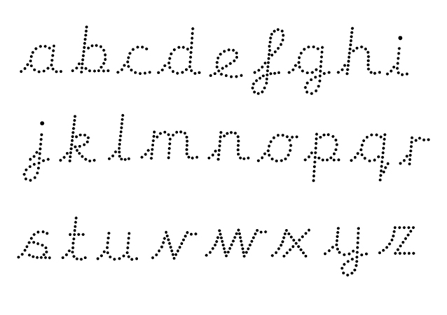

National Curriculum Requirements
The focus on handwriting in the new curriculum is much greater, highlighting its importance and making the connection between a child’s handwriting and their composition and spelling ability.

Progression:
EYFS: | Early Learning Goals:  - Use a pencil and hold it effectively to form recognisable letters, most of which are formed correctly …sit correctly at a table, holding a pencil comfortably and correctly.  - Uses a pencil and holds it effectively to form recognisable letters, most of which are correctly formed.  At Ide Hill, we follow the “Read Write Inc” Phonics scheme from Reception. The RWI scheme does not teach a cursive handwriting style. It is not a statutory requirement for EYFS children to be taught the cursive style.  The children learn the letter sounds together with their shapes as they are presented by the scheme. This allows them to develop a secure knowledge of how to form the letters. Children will, when developmentally ready, be supported to develop their handwriting so they use their phonics skills to write with independence, in line with the Early Learning Goals for Writing. This may mean that some children will begin to use a pre-cursive style and this will be encouraged. Some children may start to form cursive letters within the summer term or simply discover joins for themselves, where teaching has focused on correct formation and orientation from the beginning. For example, joining an ‘i’ to an ‘n’ with a diagonal join (as in ‘in’) or an ‘o’ to an ‘n’ with a horizontal join (as in ‘on’) are simple, natural joins that children might well use as a matter of course as they learn to write these common words. Again this will be encouraged and will, of course, support their transition into year 1.
Y1 | In year 1, the children will continue to develop their handwriting skills. Some children will remain at the pre cursive stage whilst they learn to correctly form printed letters.  Those who are developmentally ready will be encouraged to write using a cursive style. We will not force children to move from one stage to another. It is important that children are only prompted to move on when they are developmentally ready, so that they can progress in an age appropriate way that is matched to children’s natural development. The image below illustrates the importance of focusing on the child’s development as opposed to rushing the child to master the tool, which can lead to developmental damage in the body.  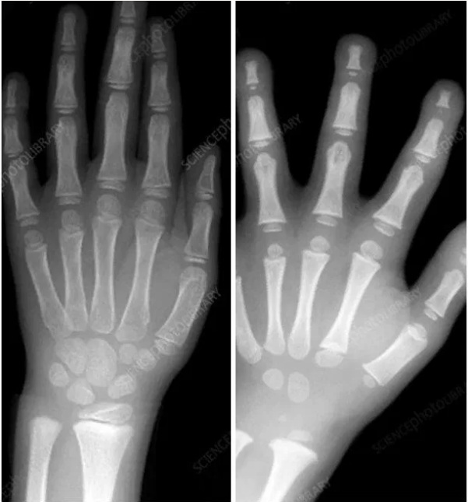  X-rays of a child’s hand at approximately 7 years of age, in comparison to X-rays of a 5 year old during the Early Years Foundation Stage (Reception).
Y2 | When children are developmentally ready, they will be taught the cursive style including how to:  - form cursive lower-case letters in the correct direction, starting from the line and joined correctly.  - form capital letters  - form digits 0-9  - understand which letters belong to which handwriting ‘families’ (i.e. letters that are formed in similar ways) and to practise these.  - form lower-case letters of the correct size relative to one another  - start using some of the diagonal and horizontal strokes needed to join letters and understand which letters, when adjacent to one another, are best left unjoined (expected year 2)  - write capital letters and digits of the correct size, orientation and relationship to one another and to lower case letters (expected Year 2)  - * use spacing between words that reflects the size of the letters. (expected year 2)
Y3 -4 | Pupils should be taught to:  * Use the diagonal and horizontal strokes that are needed to join letters and understand which letters, when adjacent to one another, are best left unjoined  * Increase the legibility, consistency and quality of their handwriting [for example, by ensuring that the down strokes of letters are parallel and equidistant; that lines of writing are spaced sufficiently so that ascenders and descenders of letters do not touch.
Y5 -6 | Pupils should be taught to:  *Write legibly, fluently and with increasing speed by  *Choosing the writing implement that is best suited for a task.

Presentation
In year 2 children will have the opportunity to earn a Silver pencil. This will be presented when children can consistently show the expected level of handwriting for year 2. Children in Years 3 and 4 will have the opportunity to earn a pen licence. This will be presented to them by their class teacher once they have identified consistently good practice. If there is a noticeable change in the child’s handwriting then they may lose the privilege of using a pen for a period of time. It is expected that all children are writing in pen in upper key stage two.
All staff will work towards a cursive style and model this whenever they are writing in front of the children or presenting children with writing they have done.

Supporting Material
http://mamaot.com/3-tricks-to-help-kids-learn-to-hold-their-pencil-correctly/
http://www.teachhandwriting.co.uk/index.html
http://www.nha-handwriting.org.uk/
http://www.bdadyslexia.org.uk/parent/help-with-handwriting

