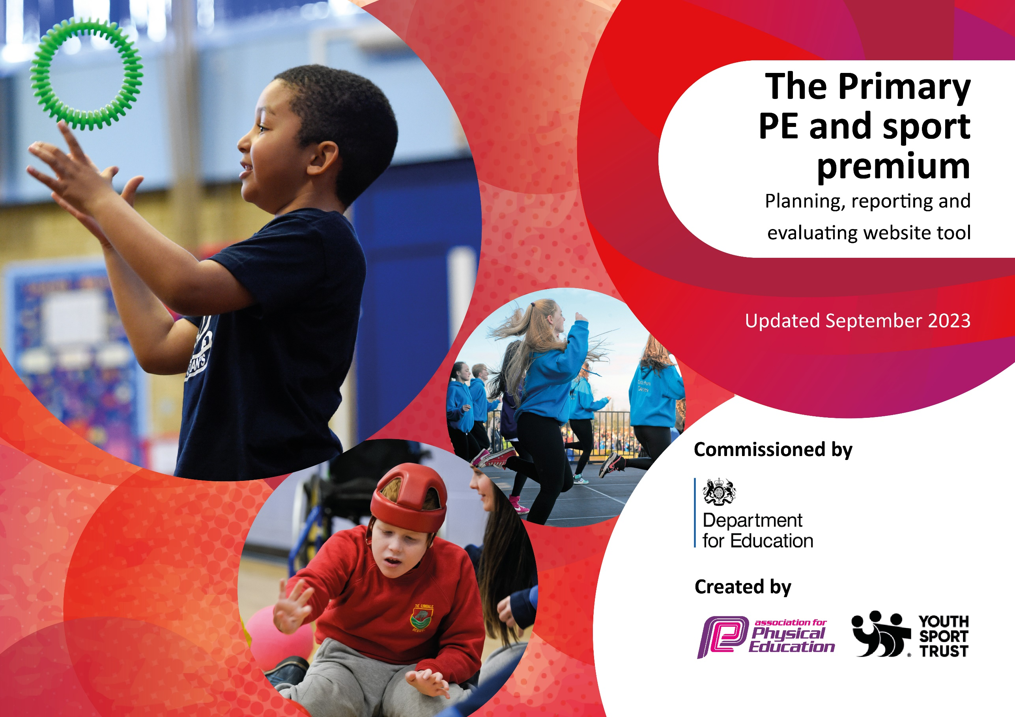

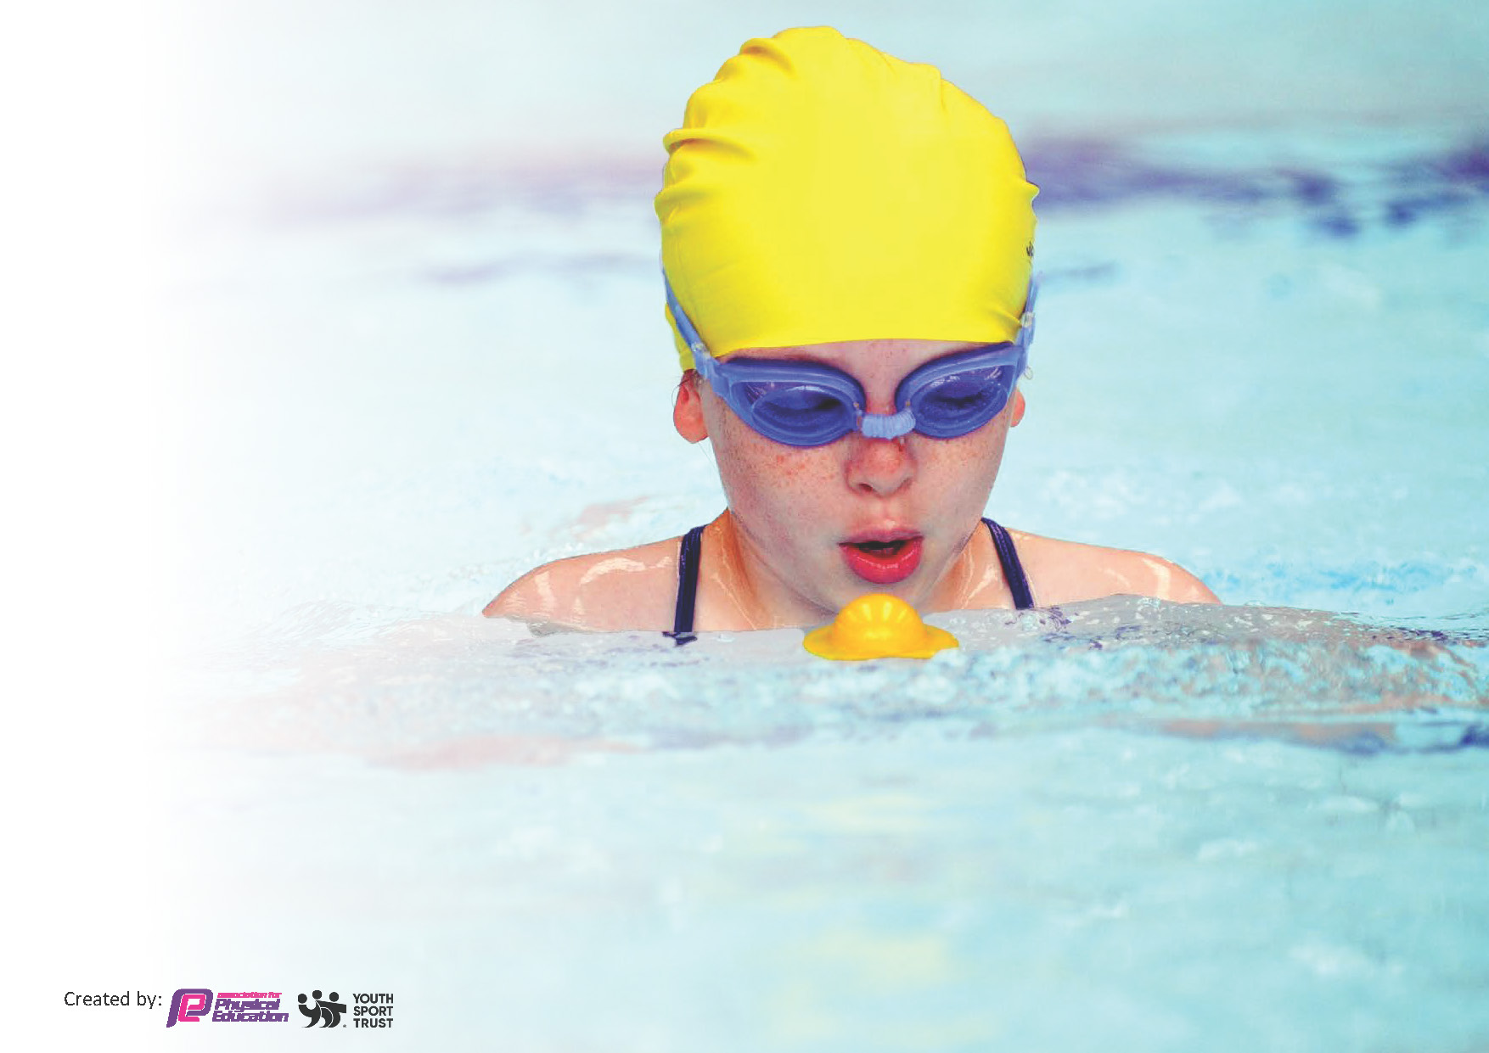
This template can be used for multiple purposes:
by:
- It enables schools to effectively plan their use of the Primary PE and sport premium
- It helps schools to meet the requirements (as set out in guidance) to publish information on their Primary PE and sport premium
- It will be an effective document to support Ofsted inspections enabling schools to evidence progress in Physical Education (PE) and evidence swimming attainment, which forms part of the PE National Curriculum. We would recommend schools consider
the Intent, Implementation and Impact of any spend, as examined within the Education Inspection Framework.

It is important that your grant is used effectively and based on school need.

Schools must use the funding to make additional and sustainable
improvements to the quality of the PE, School Sport and Physical Activity (PESSPA)
they offer. This means that you should use the Primary PE and sport premium to:

- Build capacity and capability within the school to ensure that improvements made now will benefit pupils joining the school in future years
- Develop or add to the PESSPA activities that your school already offers.

The Primary PE and sport premium should not be used to fund capital spend projects; the school’s core budget should fund these. Further detail on capital expenditure can be found in the updated Primary PE and sport premium guidance.

The Primary PE and sport premium guidance, outlines 5 key priorities that funding should be used towards. It is not

necessary that spending has to meet all the key priorities, you should select the priorities that you aim to use any funding towards.

Although completing this template is not a requirement for schools, schools are required to publish details of how they spend this funding. Schools must also outline what the impact this funding has had on pupils’ PE and sport participation and attainment and how any spending will be sustainable in the future. All funding must be spent by 31st July 2024.

The Department for Education has worked closely with the Association for Physical Education (afPE) and the Youth Sport Trust (YST) to develop this template and encourages schools to use it. This template is an effective way of meeting the reporting requirements of the Primary PE and sport premium.
Review of last year’s spend and key achievements (2023/2024)

We recommend you start by reflecting on the impact of current provision and reviewing your previous spend.

Activity/Action | Impact | Comments
- All classes involved in nature school.  - Begin to offer more clubs throughout the school.  - Embedding physical activity into the school day with active break times, active play at lunch and movement breaks.  - Providing targeted activities to support and involve the least active children.  - Good parental feedback from Sports Day  - Many children represented the school in competitive sport in county tournaments.  - Investment in play time resources  - Extension of PE activities into lunch and play time.  - Planned regular sports events planned to showcase PE to parents.  - Multi sports club available 3 times per week for 40 children.  - Governor monitoring and participation in PE greatly increased  - Strong links with Sevenoaks and Tonbridge Sports Partnership. | Many more children participating in sporting events and activities.  Children have been provided with opportunities to be more active during their breaks.  More clubs put in place across the school and more arranged for next academic year.  Children are all doing 2 hours of PE per week.  Governors clear about what is happening in PE and it’s impact. Governors play an active role. | Next year to more children to be involved in events, not just competitive events.  To give time to staff to set up activities at break and lunch.  To set up daily mile and note down other times the children have active learning breaks/movement breaks.  Further investment in PE and playtime resources  Development of the outside area for all children.  Further team teaching and CPD development for staff.  To aim for Gold Award.  More children to become involved in events and competitions throughout the school. Including interhouse events and in school opportunities.

Total Funding 2024-2025: £17,261

Key priorities and Planning

This planning template will allow schools to accurately plan their spending.

Action – what are you planning to do | Who does this action impact? | Key indicator to meet | Impacts and how sustainability will be achieved? | Cost linked to the action
The engagement of all pupils in regular physical activity –Daily Mile to be introduced by Term two for all children.  Opportunities to be provided during break and lunch for children to be active.  Provide opportunities for pupils to experience a range of sports through after school clubs  To provide opportunities within the school day for pupils to be physically active Develop pupil leadership in PE  Increase participation with outside events and competitions for all children | Teachers, Teaching assistants, pupils and admin staff | Key indicator 1: The engagement of all pupils in regular physical activity – Chief Medical Officer guidelines recommend that primary school children undertake at least 30 minutes of physical activity a day in school | Increase the opportunity for pupils to participate in extra-curricular activities, including those who are ‘less active.’  Sustainability: Overtime equipment and resources will be built up and linked with our long term plan.  Teachers will be confident in leading activities, lessons and events throughout the school. | Free places to clubs each term - £400  2 TAs to be on the playground from 8:30-8.50 for the Daily Mile to take place - £2,110 (currently within school budget)  Sevenoaks Sports Leaders (year 6) to be costed - £100  Cost of equipment for the playground to be updated termly - £730  Cost of two members of staff to go to 4 events a term  Teacher = £3,626  TA = £1,352 (TA currently within school budget)

Dedicated PE notice board implemented, achievements to be celebrated in Celebration Worship and our weekly newsletter  Termly sporting events to take place within houses to raise the profile of houses, sport and teamwork  All children to participate in at least 4 events throughout the year – either externally or externally.  Plan for opportunities for teachers vs teachers or events with parents to raise the profile and enjoyment of sport/PE. | Teachers, Teaching assistants, pupils and admin staff | Key indicator 2: The profile of PE and sport being raised across the school as a tool for whole school improvement | To share sporting success with community so children are motivated about PE and Sports and want to actively engage.  Sporting events to take place within houses  All children to participate in events internally and externally  Sustainability: Teachers will be upskilled through the use of PE pro. The lesson plans and videos will support teachers in delivering PE confidently. | Time to update notice board, make certificates and add to weekly newsletter – 1 hours per week = £608 (currently within school budget)  Costing for PE pro = £1,200  Costing for organisation of events in school – 1 hour per week = £2,220 (currently within school budget)  £600 for Colour Run
Ensure sports coaches continues to support teachers with planning and delivery.  Arrange opportunities for staff to attend CPD courses.  Assessment grids to be used at the end of every term | Teacher and Teaching assistants | Key indicator 3: Increased confidence, knowledge and skills of all staff in teaching PE and sport | Improve quality of teaching & learning in PE for non-specialist teachers. Develop staff confidence in assessment of PE  Develop staff confidence in areas of PE through courses & training  School staff to be motivated by sport and actively engaged so children and parents see this as an important area  Sustainability: Teachers will be upskilled through quality sports coaches throughout the year. Leaders will attend CPD sessions and this will be disseminated between staff for further development. | Cost of sports lessons – 1 day a week for 7 classes= £7344  CPD for staff = £500
Alternative events/activities to raise profile of sports/sporting events  A range of clubs offered during lunchtimes and afterschool for all pupils.  Arrange for alternative sports at lunchtime  Sports captains to lead sessions at lunchtimes for children across the school.  Inter house competitions across the school termly. | Teachers, Teaching assistants, pupils and admin staff | Key indicator 4: Broader experience of a range of sports and activities offered to all pupils | Increase the opportunities for children to try different sports.  Clubs to offer a variety of different activities – gymnastics, dance, musical theatre. | Cost of 2 outside agencies to come in and teach the children a different sport. = £8250 (see above)  2 free places to clubs each term - £400 (see above)  Admin support for outside club and events = £655 (currently within school budget)  Nature school – 1 class per term = £3,000 (subsidized)
Competitions- To continue to enter: - School games competitions - Local leagues - Inclusive competitions and events  Increase pupil participation by at least 10% compared to last year | Teachers, Teaching assistants, pupils and admin staff | Key indicator 5: Increased participation in competitive sport | Build on continuing success in competition academic year 2023/2024  Increased participation through entering more B and C teams and ‘friendly’ events and more of a range of events offered.  Sustainability: Support through subscriptions will provide CPD and confidence to staff. | Costing for organisation of events in school – 1 hour per week = £3,120 (see above) (currently within school budget)  Subscription to Knole and Sevenoaks Partnership Schools = £500

Key achievements 2024-2025
This template will be completed at the end of the academic year and will showcase the key achievements schools have made with their Primary PE and sport premium spending.

Term 1 review = Black
Term 2 review/additions = purple
Activity/Action | Impact | Comments | Cost
Daily Mile and active playtimes | The whole school participated in National Fitness Day and the daily mile kicked off – classes are participating in this a number of times a week. This was then celebrated with a whole school colour run including staff and parents. The afternoon was a great success and promoted the enjoyment of physical activity.  Most children are active during playtimes and equipment is on the playground for the children to participate in games or make up their own.  Ongoing. Play leaders to start in T3 within EYFS and KS1 at lunchtime. Teachers are building in time for active breaks throughout the day, this is supporting the children with focus and attention, as well as being active. |  | £800
Clubs | The amount of clubs throughout the schools has increased – offering wider opportunities for the children at various times of the day. Further clubs in term 2 focused on being active.  Ongoing – children have a range of clubs to choose from during the day and after school.  About 50% clubs have at least 1 PP child attending. 169 children attend clubs. They may attend more than 1 club. | Term 1:  Newspaper club  Karate  Homework  Games club  Coding  Fashion  Science  Choir  Term 2: Added-  Dance  Running  Drama, Dance and Theatre  Term 3: Added -  Chess  Opening up more clubs to all year groups  Netball  Lacrosse  Timestable RockStars  Lego
PE and playtime equipment | More equipment for both playtimes and PE sessions have now been ordered based on the curriculum and what the children have requested/enjoy at playtimes.  Allowing more children to be active and involved at playtimes and also more equipment for all children to actively participate in lessons.  Equipment in place for lessons and on the playground – effective lessons taking place and children being active on the playground. | To continue to monitor equipment as they do get lost at playtime. | £445.60
Increase participation with outside events and competitions for all children | 12 events added so far this academic year.  Number of children: 132. Some of these children may have had more than one opportunity.  Children attending these events are also being celebrated within Collective Worship and our weekly newsletters.  More events scheduled with a range of children participating. More events come through for Upper KS2 currently.  Children are representing the school well and all children are able to participate – this is raising self esteem, team work and opportunities. | Good attendance by parents and spectators. Good feedback. Some events have had to be cancelled because of the weather.  To become involved in more competitive opportunities when they arise as most so far have been an opportunity for all. 1 competitive football tournament.
Termly sporting events to take place within houses to raise the profile of houses, sport and teamwork | Colour run  Interhouse netball competition T2.  Creative event to promote teamwork in houses
Ensure sports coaches continues to support teachers with planning and delivery.  Arrange opportunities for staff to attend CPD courses. | Netball coach delivered two sessions in term 2 to all KS2 classes – supporting the children’s skills and also the teachers CPD. Staff have felt more confident in teaching netball.  Football CPD sent out to all staff.  Teachers using skills progression documents to inform planning and sessions.  Dance teach to teach all EYFS and KS2 classes in term 2. Supporting skills of both children and teachers. Positive feedback from staff, parents and children. Staff were actively participating and spporting CPD. |  | £600
Assessment grids to be used at the end of every term | Assessments have taken place within all classes last term. This is to take place three times per year. A good awareness of PE across the school and individual children.
To aim to achieve the PE Gold Award by the end of the year. | Meeting has taken place with lead from Tonbridge Partnership to support with the start of this goal.

Swimming Data
Meeting National Curriculum requirements for swimming and water safety.
Priority should always be given to ensuring that pupils can perform safe self-rescue even if they do not fully meet the first two requirements of the National Curriculum programme of study

Question | Stats: | Further context  Relative to local challenges
What percentage of your current Year 6 cohort can swim competently, confidently and proficiently over a distance of at least 25 metres? | 100%
What percentage of your current Year 6 cohort can use a range of strokes effectively [for example, front crawl, backstroke, and breaststroke]? | 100%

What percentage of your current Year 6 cohort are able to perform safe self-rescue in different water-based situations? | 100%
If your schools swimming data is below national expectation, you can choose to use the Primary PE and sport premium to provide additional top-up sessions for those pupils that did not meet National Curriculum  requirements after the completion of core lessons. Have you done this? | Yes/No
Have you provided CPD to improve the knowledge and confidence of staff to be able to teach swimming and water safety? | Yes/No

Signed off by:

Head Teacher: | Elizabeth Alexander
Subject Leader or the individual responsible for the Primary PE and sport premium: | Elizabeth Alexander
Governor: | Tammy Coles  Richard French
Date: | Written September 2024  Updated 28.10.24  Updated Term 2

