Dear Parents and Carers

A very warm welcome to you all and your children!

I would, firstly, like to reassure you that all the children have had a lovely first week settling into life in Saplings. There are always some wobbly moments when the children start, some children will settle in quickly and others will take a little longer. The novelty may wear off and they might decide that they don't want to come to school anymore or they will become very tired and grumpy with you as the term goes on! These are all normal behaviours. If you have any concerns or questions, please do not hesitate to speak to myself or Mrs Drysdale - our door is always open! We want this transition to go as smoothly as possible for every child and will work together with you to ensure your child is happy and enjoys coming to school.

We will all be getting to know each other this term and find out what makes us all special and unique. Together with the children, we will discover what their worlds look like, what makes each child tick and ensure everyone feels happy and secure at school. Our priority is to offer the children an enabling environment which meets the ever-changing needs and interests of each child. The children’s wellbeing and autonomy is essential to achieve the best progress and we will encourage this through building trusting relationships, setting consistent boundaries and teaching through play.

Secondly, I have some "housekeeping" items to run through with you. So please bear with me!

1. Please ensure that your child has a set of NAMED wellies + waterproofs in school asap (to go on their pegs). We will use these in our garden area and also for Nature School, so as the weather turns it is essential that your child has the correct kit in school.

2. PE days - Saplings PE sessions with Mr Taylor will be on Monday and Thursday afternoons. This means your child can come into school on those two days in their PE kits and will stay in their kits for the whole day.

3. Nature School - these sessions with Mrs Hardy will take place on a Thursday. The children will already be in school in their PE kits and will be helped to change into their waterproofs and wellies depending on the weather. The children will keep their waterproofs and wellies here at the end of each session. We can send the waterproofs home at the end of term if they need to go in the wash!

4. Snack Time - the children will be offered fruit/vegetable every day at snack time from our school provider. If your child would prefer a piece of fruit or vegetable from home, please provide it in a named container. We are a nut free, healthy school so fruit winders or cereal bars, for example, cannot be eaten in class at snack time. We also offer milk which is free whilst your child remains 4. Once they turn 5, parents will need to organise payment for milk. I believe the form with this information was included in your parent pack. The children have access to their waterbottles at all times and we encourage them to try drink up so they can refill them throughout the day.

5. Show and Share class sessions - will take place on a Monday. These sessions will start from Monday 27th September. Please see more information about these sessions below.

6. Teddy Bear's Picnic - as we were unable to do this earlier in the summer, we would like to organise something for the end of this term. Information will follow by email in due course.

7. As per the School Pack you were sent, please ensure your child has a spare set of pants/socks/tights in a bag to go on their pegs. We do have some spares but always run out very quickly. It can often be reassuring for your child to know that they have a spare set on their peg just in case!

8. Please ensure that all your child's uniform is clearly labelled, including waterbottles and coats.

9. Buddies - Saplings will be meeting their buddies from Year 5 at the end of the week. We have organised it with the Y5s this year so Saplings will get 2 years (Saplings and Y1) with their buddies. I know the Y5s are really looking forward to getting to know the children.

Thank you for your co-operation and patience with all this information! We look forward to working with you and your child over the next few weeks of this term.

Mrs Daniels and Mrs Drysdale

Personal Social Emotional Development

PSED is the initial area of learning within the EYFS, children’s personal, social and emotional development (PSED). It is crucial in their ability to lead healthy and happy lives, which is fundamental to their cognitive development.
Without the ability to feel safe and secure, children will be unable to learn new skills, or progress within their EYFS development. This extends to children feeling confident to make mistakes whilst they learn, and be able to keep going, and grow in resiliance. The Characteristics of Effective Learning underpin all areas of learning and development and link particularly to PSED.

"Getting to know you"
This term will focus on getting to know each other, what makes us all unique, our similarities and differences, who is special to us and managing our feelings.
We will use Circle Time to talk about how we can make everyone feel happy and safe with rules (making a Class Charter - UNICEF).
The children have a “home corner” role play area so they have a link with home and can build relationships with their peers through familiar experiences. We will be sending home a card frame for you to pop a family photo in. Please return it to school so we can celebrate everyone's family. They will be returned to you. Thank you.
You can help your child at home by:
- talking about people who are special to your family
- celebrating people's differences/similarities/achievements (big or small)
- talking about your child's feelings and reinforcing that it is ok to make mistakes

Physical Development

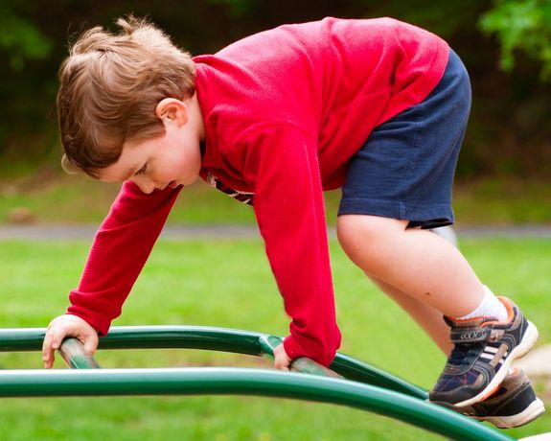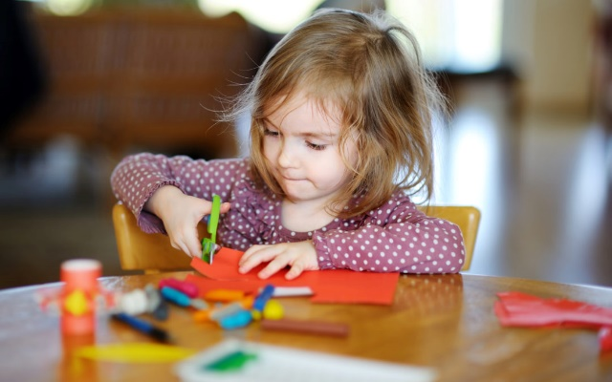

Saplings will have daily opportunities to help build and strengthen core/arms/co-ordination in order for them to write and move confidently. They will be improving their gross/fine motor skills everyday, inside and out.

Mr Taylor will start PE sessions with the children on Mondays and Thursdays which will be fun and based around throwing and catching skills to begin with.

You can help your child at home by:

- encouraging your child to build their confidence to try a new activity that gets them to be active - climbing, jumping, swimming, etc
- modelling correct scissor grip/model how to hold pencil securely and comfortably
- make your own playdough to use at home, try some digging in the garden or carrying some heavy items (within reason, of course!) from one area to another .

Communication and Language:

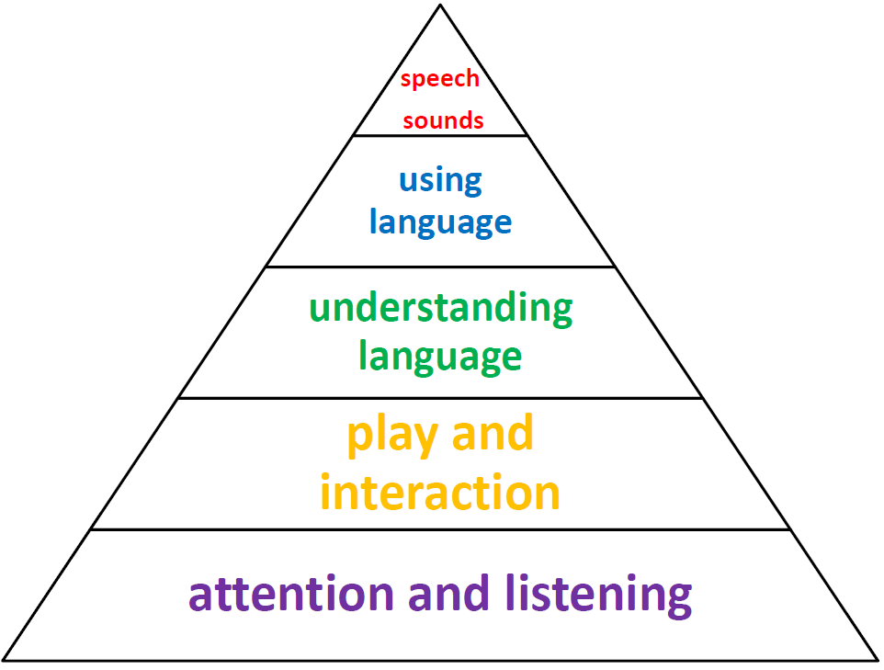

The children will have "Show and Share" on a Monday (from 27th Sept) to help develop their social and communication skills. The children can bring in something that is special to them from home for these sessions. This might be a toy, book or picture. It might be that they would like to talk about something they did at the weekend. Each child will be given a "Learning Journal" which they can use to document their weekend adventures, practice their sounds or numbers, draw a picture, etc. These will be sent home in their bookbags along with instructions. They can then use these Learning Journals at our Show and Share sessions to share something with the other children. If possible, please encourage your child to bring in 1 item for each session! So, they might choose a special toy one week and then share something in their Learning Journal the next week.
We would love to hear about your child's "WOW" moments at home or when you are out and about. You can record these in their Learning Journals. Your child might learn to ride their bike, swim further, write their name correctly or a new letter...these are all things that we want to celebrate!
We will be developing our “Talk Partner” skills during learning time, encouraging children to ask “how” and “why” questions about their experiences in response to events or stories. We will encourage the children to develop their own narratives and explanations by connecting ideas and events.
You can help at home by:
- talking to your child about a variety of subjects that interest them, introduce new words, model how to answer in a full sentence
- play talking games
- model listening in conversations and taking turns to talk

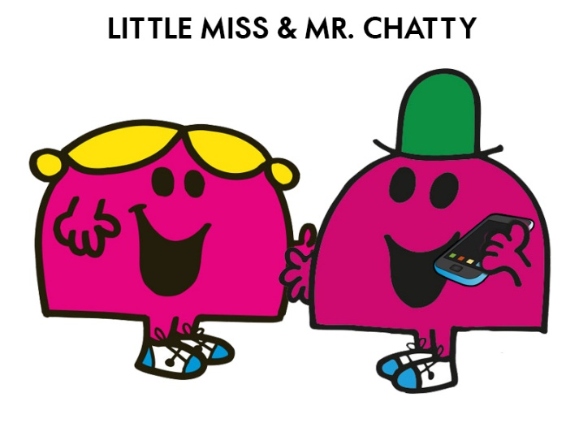
Literacy

Mark-making/writing: There will be lots of opportunities for mark making both in the classroom and outside this term, as well as activities to focus on gross/fine motor skills to encourage a strong, correct pencil grip.
You can help your child to enjoy the start of their writing and reading journey by:
- letting them draw or write at home using pens, mud, bubbles, fingers, paint, bubbles, etc! Let them draw or mark-make as big or as small as they like.
- encourage them to talk with you about the stories you read or the stories they make up, have fun with role play and small world, draw the story
- let them help you write a shopping list or create little secret messages on paper for their toys, teddies or the fairies at the bottom of the garden! Sometimes they might get a secret message sent back!

We will make their writing opportunities purposeful, using the children's interests where possible, and encourage them to have a go, learn from mistakes and try again.

Phonics/Reading: We will start our reading adventure by sending home a yellow reading record for each child. This book can be used to record your children's reading at home. Please indicate with a simple tick/initials next to the title of the book so we know it is ready to be changed. You are very welcome to add comments/questions/WOWs about your child's reading too. We love to hear how they are getting on at home!
Before we start getting to grips with our phonics scheme, the children will bring home a school book of their choice to read with you. Once you have enjoyed reading it together, please return it with your child's reading record to school (there will be a box in the classroom for the children to put them in). We will then give them the opportunity to choose a new book.
We will shortly begin our Read Write Inc phonic sessions. More information will follow about this scheme and how you can help your child at home.
Once the children are comfortable with the first few sounds that we learn in phonics, we will then begin to send home our reading scheme books. These will correspond with the sounds as they learn them. Please continue to record in the yellow reading record when you have finished with a book/comments about their reading and send them into school with your child. We will aim to change the books every day.
Putting aside some quiet time everyday to read with your child is so important. Just 5 minutes every day will make a huge difference to their learning. There will be days when your child is just too tired to read their phonics book to you. So rather than learning to read becoming a chore, please read it to them/turn it into a game so they have to spot a certain letter or word/you read a page and then they read a page, for example. Each child will learn to read in their own way and their own time. We are here to help and support you and your child.

You can continue to help your child at home by:

- Praising their attempts at using their phonics to write at home and encouraging them to use correct formation. Remind them not to give up!
- Model writing with your child - making a shopping list/sending a card.
- Picking out sounds or reading signs when you are out and about.
- Read together for pleasure - just enjoy the story and use your imaginations! Or, share a non-fiction book and learn something new together.

Maths

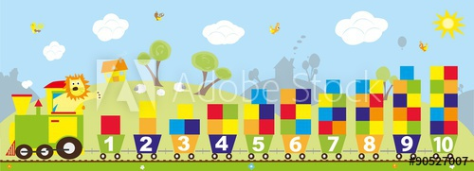

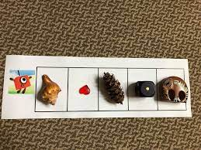

We are beginning to get to know what the children know already and what they are interested in. As the term progresses we will be focusing on numbers, “number sense” and counting, with lots of cross-curricular activities to enhance our learning. We will start with looking at the oneness of 1 up to the fiveness of five using loose parts! There will be opportunities to explore "one more, one less" and we will enjoy singing number rhymes. We will also be looking at 2D shapes and repeating patterns. You can encourage your child to look for shapes and patterns and then have a go at making their own patterns using a variety of objects.

You can continue to help your child at home by:

- look for shapes and patterns at home, remind your child of the shape name
- then have a go at making their own patterns using a variety of objects.
- use numbers that are meaningful to your child - ie. if your child is four, encourage them to find four objects or draw four things to represent that number. Encourage them to count each object carefully by moving them into a line as they count.

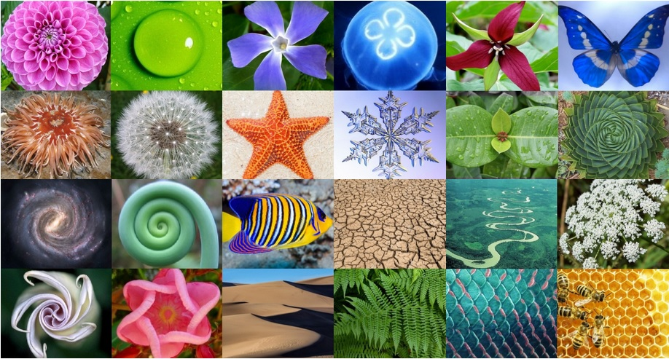

Expressive Arts and Design

Time to explore Autumn colours and colour mixing! We will be using natural materials to create collage, patterns and models. We will be creating our self-portraits too. In music, we will be using percussion instruments to recognise and match a beat, considering how loud or quiet we can be making music and listening out for the rhythm and rhyme of words.
You can help at home by:
- going on a walk and gathering some autumn treasure. We love conkers and autumn leaves!
- enjoy singing along to your favourite songs and clap to the beat
- look out for rhyming words in picture books and stories.

Understanding the World

We will celebrate our differences, likes, dislikes and consider how all children have a right to a name and nationality (Article 7, UN – Rights of the Child).
It will soon be Harvest time this term so we will be celebrating the abundance of food we are lucky enough to enjoy at Harvest and all year round!

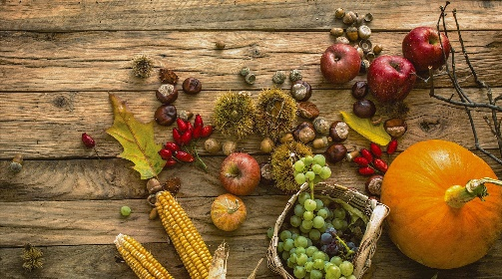

We will enjoy looking for signs of Autumn and using our senses to explore and investigate. Perhaps you can collect some natural objects for our classroom collection? The children will have the opportunity to interact with age-appropriate software and to develop their understanding of the uses of IT both in school and at home.
The children will be introduced to Mungo…our resident monkey! He loves going on trips to learn new things, so the children will have the opportunity to take him home at weekends and record their adventures in his diary. This year we will need to make sure we keep to the Covid-safe rules and this will apply to taking Mungo out and about too.

You can continue to help your child at home by:
- supporting your child to look after the world around them
- help your child use technology safely at home with an adult; take photos or find out information about an interest
- talk about your family and how special you all are

RE

We will start off by getting to know each other and then start to introduce the children to all world faiths, learning about the characters we have for each faith. This leads onto the end of term when we will focus on Christianity and then Creation. The children will explore the word "God".

This term's big question is: Who are Christians?

You can continue to help your child at home by:

- exploring and talking about how people follow different ideas/beliefs
- talk about your child's favourite stories and explain that children round the world all have their own special stories too, often from a special book
- visit a church

French

We will enjoy learning how to greet each other, count to 10, learn the names of colours, etc through games, songs, role play and stories through our everyday activities.

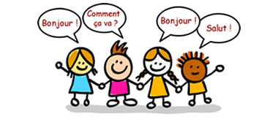

Useful information to support your child at home:

PHONICS

Please see the phonics workshop document below which sets out how we teach phonics at Ide Hill. If you have any questions, please do ask. It can be quite daunting when your child starts phonics and learning to read!

You can access the Read Write Inc website for further information/tutorials on how phonics is taught, etc. It is also possible to buy the small flashcards for the Sound Sets, should you wish to use them at home. Please do look at the link for pronunciation of the pure sounds. This is very important.

You will also find below a list of "red words" which we sometimes refer to as "tricky words". These need to be learnt by sight as you cannot sound them out. We will begin to look at these once the children are reading the phonics books and start to come across these words.

The aim is to learn 2-3 sounds a week. We started "m" today (Thursday 30th Sept) so next week we will look at "a" and "s" and so on. The order of sounds is also below so you can see what we will be learning. I will try to remember to update you all on the next two sounds coming up so you can reinforce at home.

Our lesson would roughly look like this:

Day 1 - introduce the new sound (phoneme), use flashcard and talk about picture and rhyme, play games/sound detectives/activities to help with recognition of new sound in environment, practice of saying the sound and hearing it with each other.

Day 2 - recap of yesterday's lesson, focus on formation of sound, ensuring pencil grip, begin to write sound (grapheme)- outside, big writing, games, activities, rainbow writing, etc. Our Dough Disco and Squiggle & Wiggle sessions all help to strengthen hands, wrists, arms and shoulders ready for writing.

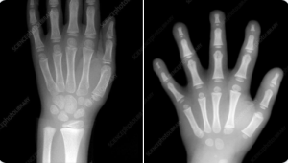

An x ray of a developed hand (around the age of 7) on the left compared to an EYFS age child’s hand on the right.

Once we have begun to explore several sounds we will then introduce how we can put certain sounds together to make simple CVC words - (c a t). Blending those sounds together helps us read the word.

