Suggested sensory circuit activities to help focus
 | 9am | After Break | After Lunch
Monday | Wall push off; place hands on the wall and bend elbows, try to touch the wall with nose (x 10)  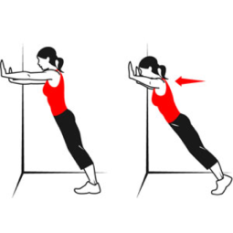 | Chair push up; push through arms on chair seat so bottom lifts off (x 10)  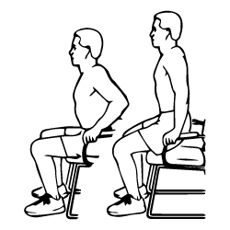 | Tummy push up; lie on stomach on the floor, elbows bent, hands near shoulders, push upper body off the floor (cobra)  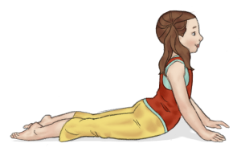
Tuesday | Joint compressions; firm pushes through each joint from head to toes, tip head forwards, back, side to side, shrug shoulders up and down (slowly and firmly), push hands together (elbows out to the side) put hands behind back and interlock fingers, squat and stand | Crab walking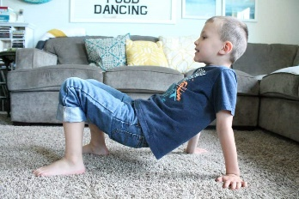 | Back to back ball (or bean bag or anything handy!) passing  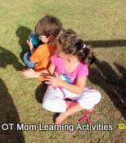
Wednesday | Happy baby pose 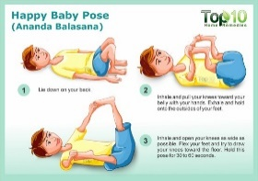 | Bunny hops x 10  Star jumps x 10 | Jog on the spot for 10 secs, then walk a tightrope, repeat
Thursday | Back to back stand up (sit in pairs back to back with arms linked, try to stand up by pushing against each other) | Tightrope walking with bean bag on head, then stand still and toss bean bag from one hand to the other | Chair push up; push through arms on chair seat so bottom lifts off (x 10)
Friday | Tummy push up; lie on stomach on the floor, elbows bent, hands near shoulders, push upper body off the floor (cobra)  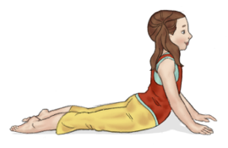 | Wall push off; place hands on the wall and bend elbows, try to touch the wall with nose (x 10) | Crab walking  Try balancing a beanbag on your tummy

