Year 1: Elms
 | Term 1 | Term 2 | Term 3 | Term 4 | Term 5 | Term 6
Maths | Number: Place value (within 10)  Number: Addition and subtraction (within 10) | Number: Addition and subtraction(within 10)  Geometry: Shape | Number: Place value (within 20)  Number: Addition and subtraction (within 20) | Number: Place value (within 50)  Measure: Length & height, weight & volume | Number: Multiplication and division  Number: fractions  Geometry: position and direction | Number: place value (within 100)  Measurement: money and time
English Reading | Apply phonics to decode words.  Read a range of simple CEW- 3 introduced each week.  Read phonetically decodable books linked to taught sounds.  Listen to and discuss a range of poems and stories.  Discuss new words and link to ones they already know. | Apply phonics to decode words.  Read a range of simple CEW- 3 introduced each week.  Read phonetically decodable books linked to taught sounds.  Listen to and discuss a range of poems and stories.  Discuss new words and link to ones they already know.  Become familiar with key stories and retell them; know their characters. | Apply phonics to decode words.  Read a range of simple CEW- 3 introduced each week.  Read phonetically decodable books linked to taught sounds.  Listen to and discuss a range of poems and stories.  Discuss new words and link to ones they already know.  Become familiar with key stories and retell them; know their characters.  Appreciate some poems, recite some by heart. | Apply phonics to decode words.  Read a range of simple CEW- revising all.  Read phonetically decodable books linked to taught sounds.  Listen to and discuss a range of poems and stories.  Discuss new words and link to ones they already know.  Become familiar with key stories and retell them; know their characters.  Read contractions in words. | Apply phonics to decode words.  Read a range of simple CEW- revising all.  Read phonetically decodable books linked to taught sounds.  Listen to and discuss a range of poems and stories.  Discuss new words and link to ones they already know.  Become familiar with key stories and retell them; know their characters.  Read contractions in words.  Read pseudo words with accuracy. | Apply phonics to decode words.  Read a range of simple CEW- revising all.  Read phonetically decodable books linked to taught sounds.  Listen to and discuss a range of poems and stories.  Discuss new words and link to ones they already know.  Become familiar with key stories and retell them; know their characters.  Read contractions in words.  Read pseudo words with accuracy.  Infer on the basis of what is said and done.
Core Text | Old Bear by Jane Hissey | Rapunsel by Bethan Woollvin | Hermelin by Mini Grey | Where the wild things are by Maurice Sendak | The Secret of Black Rock by Jack Todd-Stanton | The Lost Wolf by Mini Grey
Writing outcomes and purpose | Narrative: Finding Narrative  Purpose: To retell a story  Recount: Messages  Purpose: To inform and explain events that have happened | Narrative: A Traditional Tale  Purpose: To narrate  Instructions: How to catch a witch  Purpose: To instruct | Narrative: A Detective Story  Purpose: To narrate  Recount: Letters  Purpose: To recount | Narrative: A Portal Story  Purpose: To narrate  Information: Wild Things  Purpose: To inform | Narrative: A Return Story  Purpose: To narrate  Recount: Postcards  Purpose: To recount | Narrative: A Hunting Story  Purpose: To narrate  Instructions: Recipes  Purpose: To instruct
Word level | Build on previous year & focus on:  Regular plural noun suffix -s or -es | Build on previous units & focus on:  Reinforce plural noun suffix -s/-es Adding the suffix -er to verbs | Build on previous units & focus on:  Reinforce plural noun suffix -s/-es How the prefix un- changes the meaning of verbs and adjectives Adding the suffixes -er and -est to adjectives | Build on previous units & focus on:  Adding the suffixes -ing, -ed and - er to verbs  Adding the suffixes -er and -est to adjectives  How the prefix un- changes the meaning of verbs and adjectives | Build on previous units & focus on:  Reinforce plural noun suffix -s/-es Adding the suffixes -er and -est to adjectives  Adding the suffixes -ing and -ed to verbs  Reinforce how the prefix un- changes the meaning of verbs and adjectives | Build on previous units & focus on:  Reinforce plural noun suffix -s/-es Adding the suffixes -ing and -ed to verbs  Adding the suffixes -er and -est to adjectives
Sentence level | Build on previous year & focus on:  Combining words to make sentences  Joining words and clauses using ‘and’ | Build on previous units & focus on:  Combining words to make sentences  Joining words and clauses using ‘and’ | Build on previous units & focus on:  Combining words to make sentences  Joining words and clauses using ‘and’ | Build on previous units & focus on:  Combining words to make sentences  Joining words and clauses using ‘and’ | Build on previous units & focus on:  Combining words to make sentences  Joining words and clauses using ‘and’ | Build on previous units & focus on:  Combining words to make sentences  Joining words and clauses using ‘and’
Text level | Build on previous year & focus on:  Sequencing sentences to form short narratives | Build on previous units & focus on:  Sequencing sentences to form short narratives | Build on previous units & focus on:  Sequencing sentences to form short narratives | Build on previous units & focus on:  Sequencing sentences to form short narratives | Build on previous units & focus on:  Sequencing sentences to form short narratives | Build on previous units & focus on:  Sequencing sentences to form short narratives
Punctuation level | Build on previous year & focus on:  Separation of words with spaces Capital letters  Full Stops | Build on previous year & focus on:  Separation of words with spaces Capital letters  Full Stops | Build on previous year & focus on: Separation of words with spaces  Capital letters  Full Stops  Question mark  Exclamation mark | Build on previous year & focus on:  Separation of words with spaces Capital letters  Full Stops  Question mark  Exclamation mark  Capital Letters for names and personal pronoun - I | Build on previous year & focus on:  Separation of words with spaces Capital letters  Full Stops  Question mark  Exclamation mark  Capital Letters for names and personal pronoun - I | Build on previous year & focus on:  Separation of words with spaces Capital letters  Full Stops Question mark Exclamation mark
Phonics | 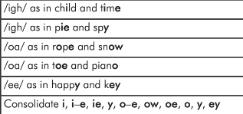 | 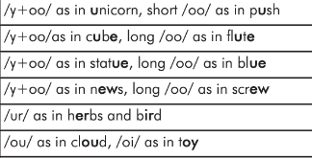 | 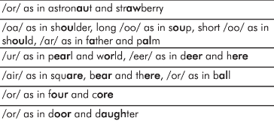 | 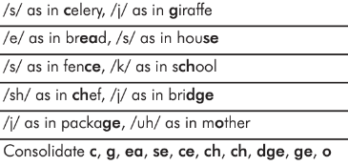 | 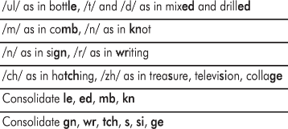 | 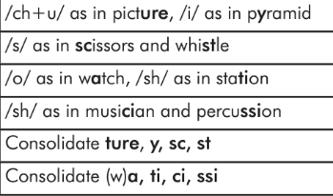
Common exception words | Teach- some, one, said, come, do, so, were, when, have, there out, like, little, what | Teach- oh, their, people, Mr, Mrs, looked, called, asked, could, water, where | Teach- who, again, thought, through, many, laughed, because, any, eyes, friends, once, please | Recap- oh, their, people, Mr, Mrs, looked, called, asked, could, water, where | Consolidate- oh, their, people, Mr, Mrs, looked, called, asked, could, water, where | Recap- who, again, thought, through, many, laughed, because, any, eyes, friends, once, please
RE  Core | GOD  What do Christians believe that God is like? | INCARNATION  Why does Christmas matter to Christians? | GOSPEL  What is the good news that Jesus brings? | SALVATION  Why does Easter matter to Christians? | A. What stories are told by and about people of different faiths and beliefs? | B. What stories are told by and about people of different faiths and beliefs?
Science | Animals including Humans:  All About Me | Exploring Everyday Materials 1 | Seasonal Changes | Exploring Everyday Materials 2 | Plants | Animals including Humans:  All about animals
Computing | 1.1 Online safety  1.9 Technology outside school | 1.2 Grouping and sorting | 1.6 Animated story book | 1.3 Pictograms  1.8 Spreadsheets | 1.5 Maze explorers | 1.7 Coding
PSHE | Me and My Relationships | Valuing Difference | Keeping Myself Safe | Rights and Responsibilities | Being my best | Growing and Changing
Music | Keeping the pulse- My favourite things | Tempo- Snail and the mouse | Dynamics- Seaside | Sound patterns- Fairytales | Pitch- Superheros | Musical symbols- Under the sea
PE | Multi-Skills  Dance | Multi-Skills  Handball/Hoopball | Gymnastics  Pupil Profiling | Football/Futsal | Rounders  Pupil Profiling | Athletics/Sports Day  Prep
History | - | How am I making history? | - | How have toys changed? | - | How have Explorers changed the world?
Geography | What is it like here? | - | What is the weather like in the UK? | - | How is life different in China? | -
Art | Sketchbook & drawing: Spirals | Print, colour and collage: Printing | - | - | - | Working in 3D: Birds
DT | - | - | Mechanisms: Moving books | Textiles: Puppets | Food:  Fruits and vegetables: Smoothies | -
Possible enrichment | - Village/ Autumn walk  - Postman visit | - Grandparents in  - Print Christmas cards KS1  - Nativity | - Create weather station in class  - Winter walk local  - Class assembly | - Set up toy museum in class and invite parents in  - Invite visitors with toy | - Chinese visitor- Penny Lam  - Spring walk local | - Trip to London  - Explorer in  - Owl visitor

